Doris (Zeringue) Hymel

February 14, 1930 – December 1, 2018

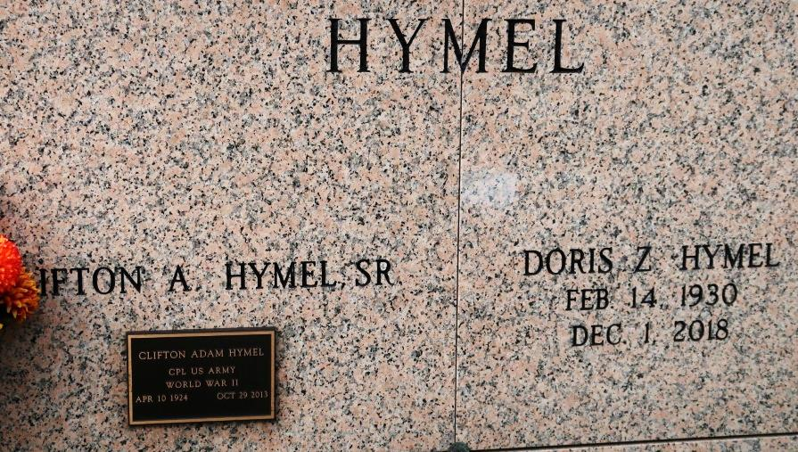

Doris Zeringue Hymel, 88, passed away on December 1, 2018 surrounded by her loving family. She was a native of Burnside and resident of St. James. Doris was born on Valentine's Day, February 14, 1930. Doris was a devoted Catholic who cherished her faith and her church. She was a loving wife, mother, grandmother and great-grandmother. She enjoyed cooking, plants, flowers and spending time with her family.

Doris leaves behind to cherish her memory her four children, Sandra Hymel Dutreix and husband, Chris, Jeanie Hymel , Clifton Hymel Jr. and wife, Sharon and Thomas Hymel and wife, Darlene; one daughter-in-law, Monica Hymel; eight grandchildren; five great grandchildren and two brothers, Roland and Norman Zeringue.

She is preceded in death by her husband, Clifton "Kippy" Hymel of 63 years; son, Steven Hymel; grandson, Bradley Hymel; parents, Leopold and Cecile Zeringue and two infant brothers. Visitation will be held on Wednesday, December 5, 2018 at St. James Catholic Church in St. James from 8am until Mass of Christian Burial at 12pm. Interment to follow in the mausoleum.

The Advocate, Baton Rouge, LA

December 3, 2018  
Contributed by Jane Edson