Jules Francois Hymel

October 9, 1904 – April 14, 1994

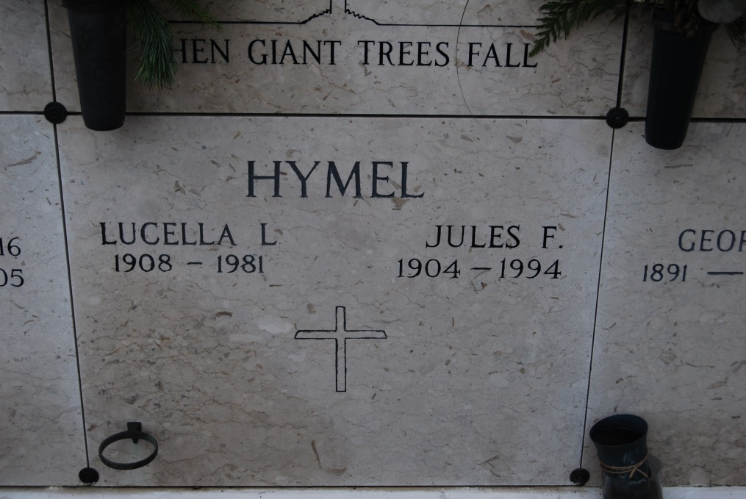

Photo by Kerry Keller

A Mass of Christian Burial will be celebrated at 11 a.m. Saturday at St. James Catholic Church in St. James for Jules Francois Hymel, 89, a native and resident of St. James Parish, who died at 11: 20 a.m. Thursday April 14. Visitation will be 8 a.m. to funeral time Saturday at the church. Burial will be in the church cemetery.

He was the father of Kelsey, Eddie, Warren and Herman Hymel, Audrey Becnel, Carolyn Kliebert, Sylvia Bourgeois, Janet Ponson and Jane Riviere; brother of Roland, Eula and Hilda Hymel. He is also survived by 22 grandchildren and 24 great-grandchildren.

He was preceded in death by his wife, Lucella Loupe Hymel; parents, Valsin and Aurelie Abadie Hymel; two brothers, Francis and George Hymel; four sisters, Elvina Hotard, Elise, Darvina and Celima Hymel; and a grandchild, Sharon Hymel Ledet.

The family requests donations for masses. Thibodaux Funeral Home, Inc. is in charge of arrangements.

Unknown source

Contributed by Roni