Lucella (Loup) Hymel

September 15, 1908 – May 14, 1981

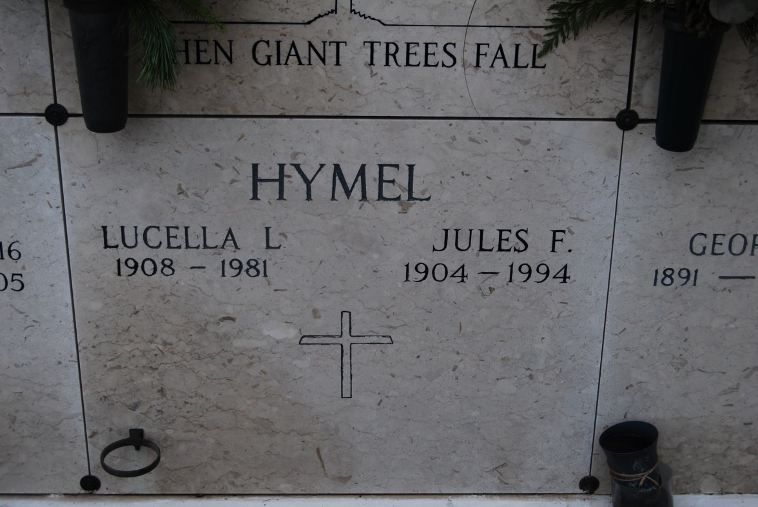

Photo by Kerry Keller

Died at 1:30 p.m. Thursday, May 14, 1981, at Thibodaux General Hospital. She was 72, a native of Wallace and a resident of St. James.

Visiting at St. James Catholic Church from 6 to 10 p.m. Friday and from 8 to 10:45 a.m. Saturday with religious services at 11 a.m., the Rev. Gerald Young officiating. Entombment in church mausoleum.

Survived by her husband, Jules Hymel; five daughters, Mrs. James (Audrey) Becnel, New Orleans, Mrs. Carroll (Janet) Ponson and Mrs. Lionel (Sylvia) Bourgeois, both of Thibodaux, Mrs. Autry (Jane) Rivere, Baton Rouge, Mrs. Alcee (Carolyn) Klibert, Vacherie; four sons, Kelsey and Eddie Hymel, both of Vacherie, Herman Hymel, St. James, and Warren Hymel, Baton Rouge; three sisters, Mrs. Laurent Waguespack and Mrs. Henry Burch, both of Vacherie, and Mrs. Joe Boindello, Baton Rouge; three brothers, Nemour and Felicien Loup, both of Vacherie, and Roy Loup, Lake Charles; 23 grandchildren; a great-grandchild. Preceded in death by a brother, Ferdinand Loup.

Masses preferred. Caballero Funeral Home, Donaldsonville, is in charge of arrangements.

Morning Advocate, Baton Rouge, LA

Friday, May 15, 1981, p. 8C  
Contributed by Jane Edson