Anthony C. Johnson

January 6, 1960 – April 29, 2007

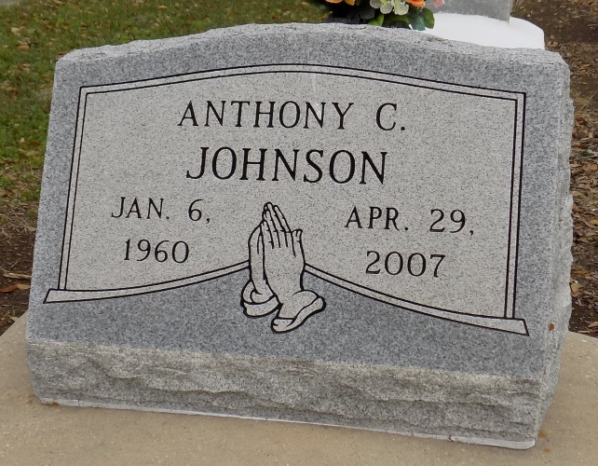

Johnson, Anthony "Papa" - A native of Donaldsonville and a resident of Gonzales, he died Sunday, April 29, 2007, at Our Lady of the Lake Regional Medical Center in Baton Rouge. He was 47.

Visiting at St. James Catholic Church, St. James, on Saturday, from 8:30 a.m. until Mass of Christian Burial at 11 a.m., with the Rev. Tim Oubre, celebrant. Burial in the church cemetery.

He is survived by his wife, LaShelle Mitchell Johnson of Gonzales; son, Marquell Harris of Baton Rouge; two daughters, Jaleesa Harris of Baton Rouge and Twanrica Johnson of Donaldsonville; sister, Margaret Johnson of Gonzales; father-in-law and mother-in-law, Henry and Laura Mitchell of St. James; two brothers-in-law, Henry III and Rajon Mitchell, both of St. James; and a host of other relatives and friends.

He was preceded in death by his mother, Margaret Johnson; three brothers, Herman Williams Jr., Mark Anthony Johnson and Joseph Wesley;   
and grandfather, Vincent Landry Sr.

Arrangements entrusted to Williams ***&*** Southall Funeral Home of Donaldsonville, (225) 473-1900.

The Advocate, Baton Rouge, LA

May 4, 2007