Wanda Denise Joshua

October 26, 1961 – September 20, 2015

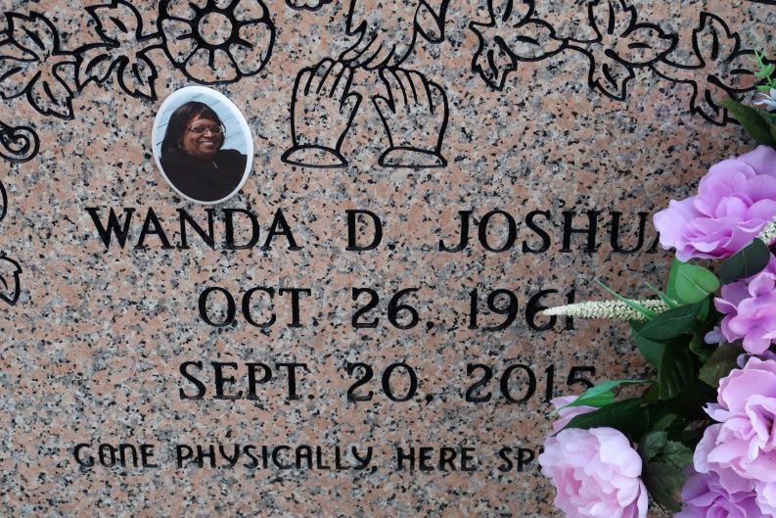

Wanda Denise Joshua, God saw you were getting tired and a cure was not to be, so He put His arms around you and whispered, "Come to me". Wanda passed on Sunday, September 20, 2015.

Wanda is survived by her parents, David and Joann Albert Joshua; her son, Josef Albert Bell; 2 sisters, Bonnie Joshua Haydel of St. James, LA and Marcia Joshua of Laplace, LA; niece, Brooklyn Haydel; nephew, Myles David Haydel of St. James, LA and many relatives, co-workers and friends.

She was preceded in death by a daughter, Tiah Brown; maternal grandparents, Joseph and Corrine Albert and paternal grandparents, Namon, Sr. and Florence Joshua.

Wanda was a 1979 graduate of St. James High School and a 1988 graduate of Westside Vocational Technical School as a licensed practical nurse. Wanda had a passion to care for the elderly.

Special thanks to the entire staff at Promise Hospital – Mancuso; caregiver, Gloria Jones; Eucharistic Minister, Lenette Braud and special and loving friends; Monique Edwards, Michelle Harris, Renee McKinney Washington and Cynthia Lewis Clifton.

Relatives and friends of the family are invited to attend the Funeral Mass of Christian Burial at St. James Catholic Church, 6613 LA Hwy. 18, St. James, LA on Saturday, September 26, 2015 at 11:00 am, with Father Christopher Decker as celebrant; Visitation will begin at 9:00 am; Interment: Church Cemetery; Arrangements by DW Rhodes Funeral Home, 3933 Washington Ave.; Please visit [www.rhodesfuneral.com](http://www.rhodesfuneral.com/) to sign the guest book.

Published by The Advocate (Baton Rouge, LA)

Sep. 25 to Sep. 26, 2015.