Ethel (Celestin) Knight

July 23, 1917 – October 13, 2015

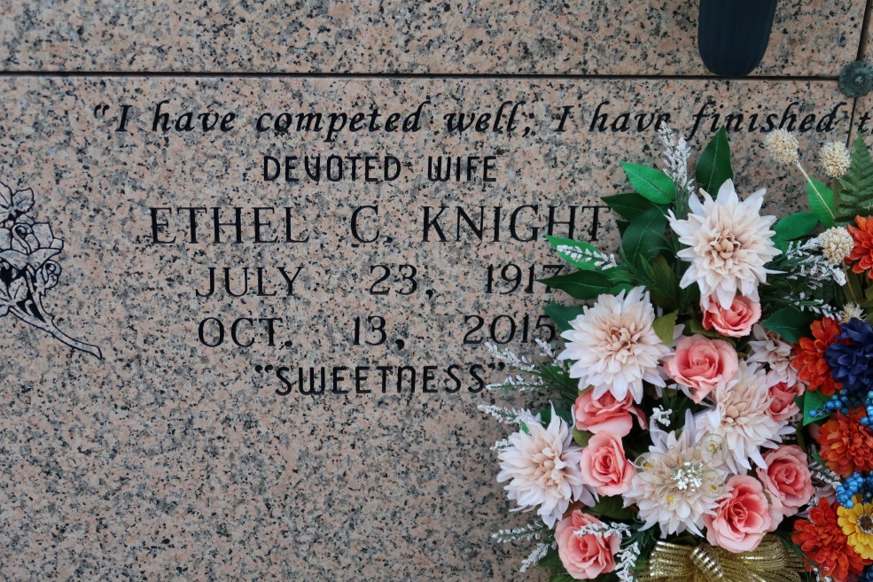

I have competed well; I have finished the race; I have kept the faith. 2 Timothy 4:7. Ethel C. Knight, "Sweetness", passed away at the age of 98 on Tuesday, October 13, 2015 at Baton Rouge General Hospital on Bluebonnet in Baton Rouge. She was a native and resident of St. James and a former resident of New Orleans.

Ethel is survived by her four children, Lois Knight, Larry Knight, Sr., Aubrey Knight, and Yvonne Smith; brother, Horace Celestin; one sister-in-law, Dorothy Celestin, 13 grandchildren; 21 great-grandchildren; and two great-great-grandchildren.

During her lifetime, Ethel met and befriended many people. She never met a stranger, and people loved her outgoing personality. Many people were beneficiaries of her kindness, generosity, and fun-filled life. She loved celebrations of all kinds, especially her well known birthday parties. Almost daily, she would go to the St. James Senior Citizens Center, where she met and enjoyed the company of not only the participants, but the staff as well. At the Center and in the community, she was called Sweetness, a name that described how she interacted with family and friends. She has also been called a pillar of the community.

Those who preceded her in death and welcomed her to her heavenly home include her parents, Willie and Elnora Celestin; her husband, Dan Knight; one daughter, Bernice K. Washington; three brothers, Louis, Willie, Jr. (Dollin), and Lionel; and other relatives and friends.

Visitation will be on Saturday, October 24, 2015, at 10:00 a.m. at St. James Catholic Church, St. James, LA, followed by the mass of Christian burial at 11:00 a.m. Interment in St. James Catholic Church cemetery. Arrangements entrusted to Treasures of Life Center for Funeral Services, 315 E. Airline Highway, Gramercy, LA 70052, 225.256.4039.

The New Orleans Advocate, Louisiana

October 22 - 24, 2015