Junius A. Landor

May 1, 1952 – July 17, 2010

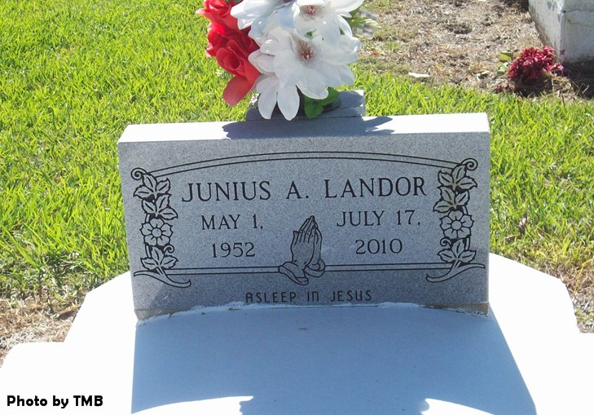

Junius A. Landor, 53, passed away Saturday, July 17, 2010, in LaPlace. He was the son of Leona Nicholas Landor and the late Junius Landor Sr., husband of Janet Isom Landor, father of Jarvis and Jarrett Landor, stepfather of Staff Sgt. Jovonne and Kwanza Isom and Sgt. 1st Class Craig S. Stewart Jr., brother of Edgar Landor and Deborah Jackson, and the late Suzanne Landor. Also survived by six grandchildren, nieces, nephew, mother-in-law, brothers-in-law, sisters-in-law and cousins. He was a member of Knights of Peter Claver and St. James Hunting Club.

Relatives and friends of the family, priest and parishioners of St. James Catholic Church and all neighboring churches, employees of SGS petroleum, St. Charles Parish schools, ADM and Workforce Alliance are invited to attend the funeral service Saturday July 24, at St. James Catholic Church, 6613 La. 18, St. James, at 11 a.m., with the Rev. L. Oubre officiating. Visitation from 8:30 a.m. until service. Interment in the church cemetery.

Professional service entrusted to Hobson Brown Funeral Home, Garyville 70051 (985) 535-2516.

The Advocate, Baton Rouge, LA

July 23, 2010