Amy Ann (Hymel) Laurent

June 29, 1932 – February 20, 2015

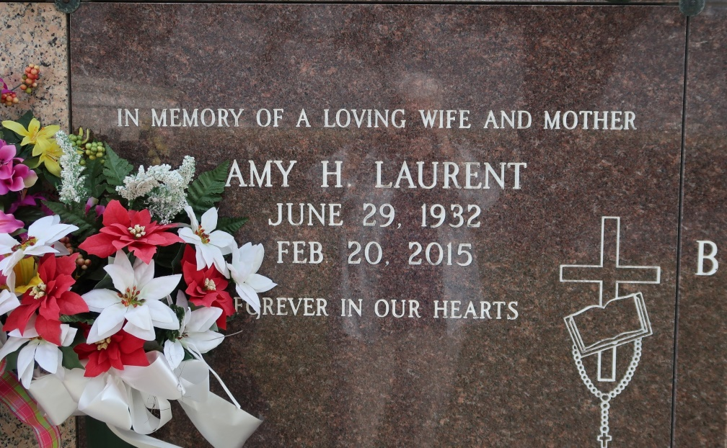

Amy Anne Hymel Laurent, 82, a lifelong resident of St. James passed away on Friday, February 20, 2015. Amy is survived by her husband of 59 years, Lloyd "Peanut" Laurent; three daughters; Andrea and husband, Nathan Folse, Bonnie and husband, Troy Zeringue, and Jenifer Laurent; one son, Anthony Laurent and Lisa Danos; three sisters, Lucille Bye (Ivy), Edith Laurent, Therese Gonzales; two sisters-in-law, Martha Hymel and Doris Hymel; one brother, Lloyd Hymel (Lillian); nine grandchildren, Nathan Folse Jr. (Theresia), Emily Hutchinson (Daniel), Boyd Laurent, Ryan Laurent, Nicholas Danos, Victoria Zeringue (Anthony Nassar), Troy Zeringue Jr., Colin Rougee ( Amber Coupel) ,and Casey Crutchfield; three great-grandchildren, Henry Folse, Tristan and Arya Jane Nassar, and two blessings on the way.

Preceded in death by her parents, George and Marie Hymel; five brothers, George, Merlin, Nelson, Ivy, and Clifton "Kippy" Hymel; brothers-in-law, Stephen Laurent, Luke Granier, Joseph Gonzales; two sisters, Eunice Hymel and Mabel Granier; two sisters-in-law, Inez and Martha C. Hymel; one granddaughter, Baby Rougee.

Visitation will be held at St. James Catholic Church on Tuesday, February 24, 2014 from 8:30 am until Mass of Christian Burial at 11:00 am. Entombment will follow in St. James Catholic Church mausoleum. Nathan Folse Jr., Boyd Laurent, Ryan Laurent, Colin Rougee, Troy Zeringue Jr., Casey Crutchfield, and Nicholas Danos will serve as pallbearers. Ourso Funeral Home, Donaldsonville, Louisiana is in charge of arrangements.

Published on TheAdvocate.com

Feb. 21 to Feb. 24, 2015