Anna Mae (Zeringue) Ledet

February 16, 1927 – January 10, 2017

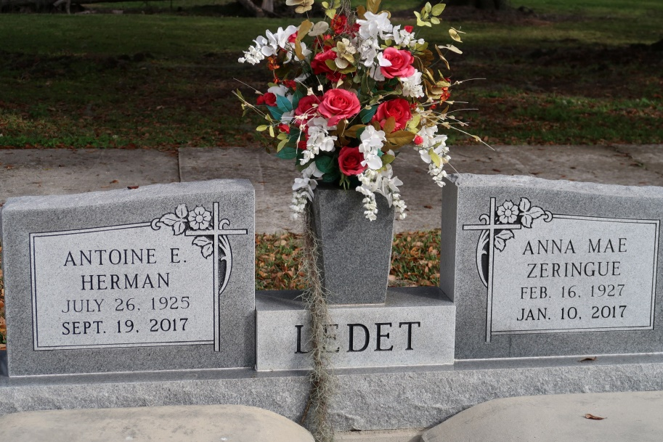

Anna Mae Zeringue Ledet, 89, a native of St. James, LA, and resident of Chackbay, LA, passed away on Tuesday, Jan. 10, 2017. She was an amazing mother, grandmother, great-grandmother and friend to many. She was also a longtime member of Christian Mothers, St James Catholic Church Choir, St James Catholic Eucharistic Minister, Lector, Commentator and CCD Teacher.  
 She leaves behind to cherish her memory her childhood sweetheart who she married on April 12, 1947, and would have been married to for 70 years, Antoine "Herman" Ledet; three children, Kathleen (Chris Sr.) Granier, Molly (Buddy) Grobe, and Herman (Lydia) Ledet; eleven grandchildren, Amy (Wallace) Gauthreaux, Cindy Daggs, Francis (Joan) Delatte, David Grobe, Sherrie (Israel) Steib, Jamie (Jene') Ledet, Kim Ledet, Lynn (Jackie) Granier, Clay (Leigh) Granier, Chris (Brooke) Granier and Troy (Nicole) Granier; twenty six great-grandchildren; and two sisters, Ethel Z. Oubre and Lillian Z. Ledet.  
 Anna is preceded in death by her son, Russell Ledet; parents, Albert and Regina Zeringue; siblings: Albert Zerinuge, Jr., Therese Z. Folse, and Aline Z. Becnel; grandson-in-law, Jerome Daggs Jr., great granddaughter, Anna Grace Delatte.  
 Visitation will be held on Friday, Jan. 13, 2017, at St James Catholic Church from 8 a.m. until Mass of Christian Burial at 11 a.m. Burial to follow in Church Cemetery. Ourso Funeral Home of Donaldsonville is in charge of arrangements.  
 The family would like to thank: Dr. Chester Boudreaux and staff, Divinity Home Healthcare, Lafourche Home for the Aged and staff. Caregivers: Rolande Naquin, Cheryl Mahler, Janice Waguespack and Carolyn Caillouet.  
 Pallbearers will be: Jamie Ledet, Lynn Granier, Clay Granier, Francis Delatte Jr., Chris Granier Jr., Troy Granier and David Grobe.

Houma Today, Terrebonne Parish, Louisiana

January 11 - 12, 2017