Antoine E. Herman Ledet

July 26, 1925 – September 19, 2017

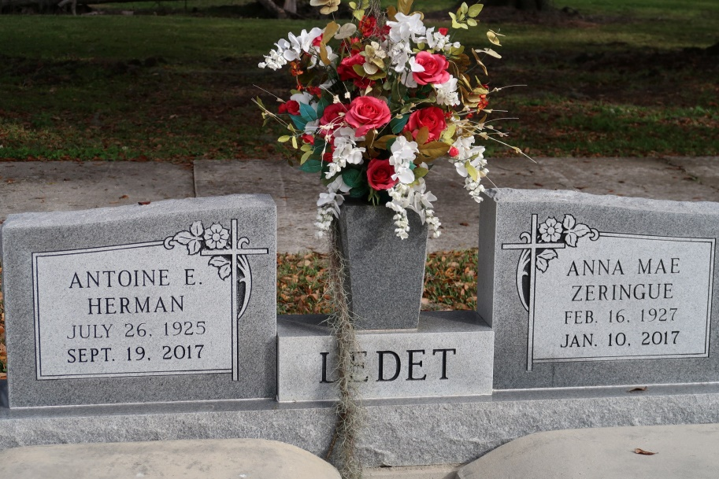

Antoine E. Herman Ledet, 92, born on July 26, 1925, a native of St. James, Louisiana and a resident of Chackbay, Louisiana, passed away on Tuesday, September 19, 2017.

He was a wonderful father, grandfather, great grandfather, brother, and friend to many. He was a US Army Veteran who served in WW II. He was a long time parishioner of St. James Catholic Church where he was willing to help out with church fairs and projects when needed. Herman loved to garden and shared his bounty with family and friends. He also loved fishing, hunting, going to Cocodrie with his children and grandchildren, and working in his workshop. He could fix and repair everything he worked on! He was always ready for a great debate and any topic or issue was welcomed. He also loved playing pedro with family and friends. He retired from St. James Co-Op after 40 years of employment.

As he enters into eternal life, he will meet his loving wife and childhood sweetheart, Anna Mae Zeringue Ledet, whom he cared for with kindness and compassion for 70 years. He leaves behind to cherish his memory, his three children, Herman "Doucie" (Lydia) Ledet, Kathleen (Chris, Sr.), Granier, and Molly (Buddy) Grobe; eleven grandchildren, Sherrie (Isreal) Steib, Jamie (Jene') Ledet, Lynn (Jackie) Granier, Amy (Wallace, Jr.) Gauthreaux, Kim Ledet, Clay (Leigh) Granier, Cindy Daggs, Francis, Jr. (Joan) Delatte, Chris, Jr. (Brooke) Granier, Troy (Nicole) Granier, and David Grobe; twenty-six great grandchildren; two sisters, Diane St. Pierre and Elizabeth "Betty" Mundine; and a brother, Alfred "Al" Ledet.

He was preceded in death by his wife Anna Mae Ledet; son, Russell Ledet; parents, Norris Antoine Ledet and Emmaline Tabor Ledet; brother, Raymond Ledet; grandson-in-law, Jerome Daggs, Jr.; and great granddaughter Anna Grace Delatte. The pallbearers will be Jamie Ledet, Lynn Granier, Clay Granier, Francis Delatte, Jr., Chris Granier, Jr., Troy Granier, Raymond Ledet, Jr., and David Grobe. Visitation will be held on Friday, September 22, 2017 at St. James Catholic Church in St. James, Louisiana from 9 am until Mass of Christian burial at 11 am. Burial to follow in church cemetery.

The family would like to thank the staff of Divinity Home Health, Journey Hospice, and sitters for their care.

The Advocate, Baton Rouge, Louisiana

September 20 - 22, 2017