Tarrell Anthony Leon

October 25, 1988 – July 7, 2010

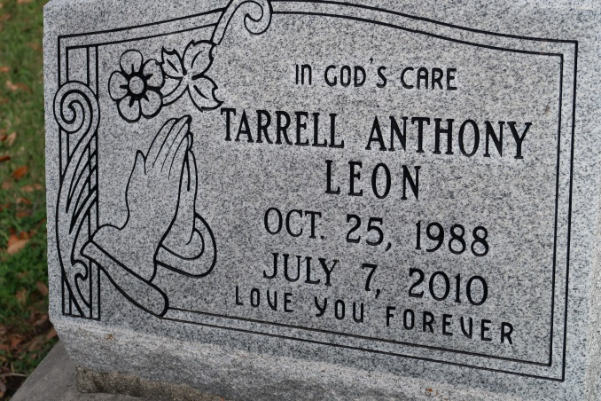

Tarrell Leon, A native of Donaldsonville and a resident of St. James, died Wednesday, July 7, 2010, in St. James at 11:30 p.m. He was 21.

Visiting at St. Catherine of Sienna Catholic Church, 421 St. Patrick St., Donaldsonville, Mass of Christian Burial conducted by the Rev. Thaddeus "Ted." Interment in St. James Catholic Church Cemetery in St. James.

Survived by his mother, Linda Celestine Leon; father, Mathieu Leon Jr.; brothers, Mathieu III and spouse Nerissa Leon, Darnell, and Darrell and spouse Krashina Broden Leon; maternal grandmother, Dorothy W. Celestine; aunts and uncles, Deidre and Adam Davis, Wanda Brown, Shelia and Larry Carr, Paulette and James Maull, Katherine and Kevin Levy, Elvincent and Carol Celestin, Grace and Eric Oubre, Mary and Nathaniel Chopin; and nieces, nephews, cousins, other relatives and friends.

Preceded in death by his paternal grandparents, Mathieu Leon Sr. and Doris Schomberg Leon; maternal grandfather, Lionel Celestin Sr.; and uncles, Louis and Lionel Celestin Jr.   
 Arrangements by Brazier-Watson Funeral Home, Donaldsonville.

Unknown source