Marie (Mitchell) Lewis

December 3, 1932 – January 12, 2022

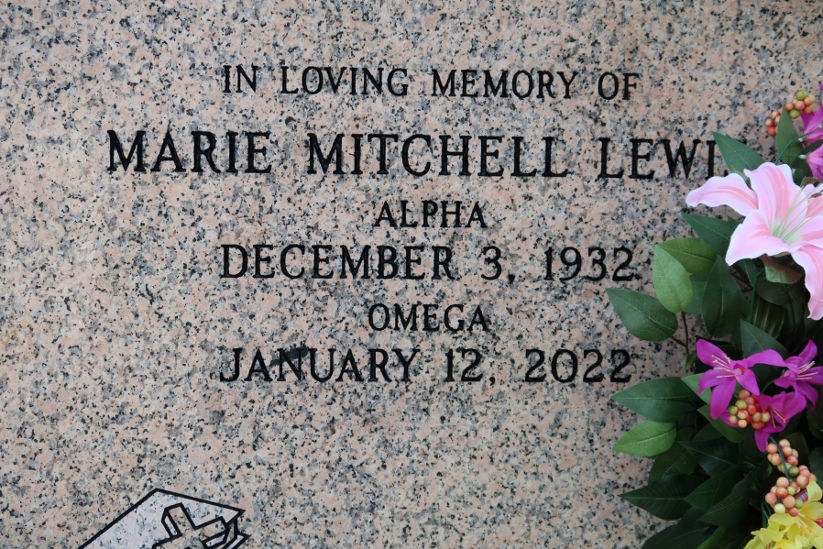

A native and resident of St. James. Marie Mitchell Lewis passed away at her residence on Wednesday, January 12, 2022. She was 89.

A public Visitation will be held on Saturday, January 22, 2022 at St. James Catholic Church, St. James, from 9:30 a.m. until 10:50a.m. followed by Mass of Christian Burial at 11:00 a.m., Celebrated by the Rev. Matthew McCaughy. Entombment in Church Mausoleum. Masks Must Be Worn At All Times.

Survived by a daughter, Cynthia Clifton. Sons, Gerard (Joyce) Lewis, John (Myrna) Lewis and Chris Lewis. Sister, Louise (Hubert) Taylor. Brothers, Paul (Joann) Mitchell, Peter (Lottie) Mitchell, Sr. and Leo Mitchell, Sr., 6 grandchildren, 9 great-grandchildren, an aunt, Cecile Melba. Numerous nieces, nephews, cousins, other relatives and friends.

Preceded in death by her parents, Ozema Mitchell, Sr. and Albertha Moody Mitchell. Husband, Harris Lewis. Sisters, Dorothy Sheppard, Albertha Thomas and Marva LeBeouf. Brothers, James, John, Roy and Ozeme Mitchell, Jr.

Brazier-Watson Funeral Home in Charge of Arrangements.

Tributearchive.com