Glenda (Ambrose) Lumar
March 25, 1945 - July 12, 2023

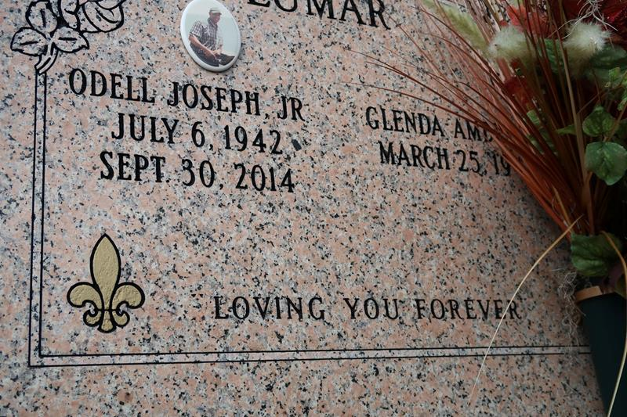

Our Mother always surrounded herself with her family, which is where she felt most comfortable and loved, and that’s where she took her last breath, peacefully with her family by her side. On Wednesday, July 12, 2023 at 9:58 pm, the Lord saw that despite the pain and suffering his child Glenda was enduring, he knew that she would continue to sacrifice her suffering for the sake of her family. He knew that she was worn and tired and a cure was not to be, so He put his loving arms around her and gently whispered, “You have fought a good fight my good and faithful servant, and it was well done, come on home.”
Our Mother, Glenda Ambrose Lumar was born on March 25, 1945 to the late Lawrence Ambrose Sr and Lucille Rodney Ambrose in New Orleans, Louisiana. Our Mother, was baptized in the Catholic faith at St. James Catholic Church. She graduated from Magnolia High school in 1962 and then continued her education at The Southern University in Baton Rouge, Louisiana. On January 2, 1965. Our Mother, was united in holy matrimony to our father, Odell Joseph Lumar Jr. To this union, 6 children were born, Schiwyn Lumar Joseph, Schelita Lumar, Scherell Lumar- Sterling, Odell Lumar III, Terrill Lumar and Tresha Lumar-Bartholomew. Our Mother, was employed at St James Parish Sheriff Department up until her retirement. She was a member of the Ladies Auxiliary Court No 135, where she served until God called her home.
Our beautiful mother, was a loving, caring and supportive mother, grandmother, great- grandmother, sister, sister-in-law, aunt and cousin. But let’s get one thing clear, even though she was loving and caring, she definitely didn’t mind giving you a piece of her mind and telling you about yourself rather you liked it or not but it was all done out of love. Our mother, was a classy feisty young lady. She was her own unique fashionista. She enjoyed shopping, she didn’t mind spending her last dollar on a good pair of high heels or a purse. Her most favorite past time was spending time in her flower garden. Our mother had the magic touch of bringing dead flowers back to life. Our mother showed us unconditional love. She enjoyed and loved spending quality time with her family, which was her pride and joy. She was there for ALL the milestones of all her children, grandchildren and great-grandchildren. She taught us the true meaning of being there for FAMILY, to love one another and to always stick together as a family no matter what. What a legacy of leave?
Glenda leaves to cherish her memories 4 daughters; Schiwyn (Rev.Carnel) Joseph of Belle Rose, La; Schelita Lumar of Laplace, LA; Scherell Lumar-Sterling of Vacherie, La; Tresha (Jamie) Bartholomew Sr. of Wallace, la; 2 sons; Odell Lumar, III of Wallace, La, and Terrill Lumar Sr. of Vacherie, La. 1 brother Lawerance Ambrose Jr of St. James, La; 2 brother-in-laws, Adam Lumar and Berman Washington; 6 sister-in-laws, Pauline Ambrose, Delores Lumar, Marva Lumar Washington, Betty Lumar, Deborah Lumar and Ann Lumar; 10 grandchildren, Rashad Lumar, Rachard Lumar, Terrill Lumar, Juwan Lumar, Darnell Wheaten Jr, Jamie Bartholomw Jr, Sharae’ Hamilton, Janai Bartholomew, Destiny Wheaten, and Kaylyn Lumar. 5 Great Grandchildren, a host of step-grand-children, nieces, nephews, godchildren and other relatives and friends.
She was preceded in death by her husband Odell Joseph Lumar Jr, her parents Lawrence and Lucille Ambrose Sr, one brother, Clarence Ambrose, a host of other relatives and the apple of her eyes, her puppy Princess. “I leave the world a better place, because of my children and their children; they are my most beautiful and treasured legacy. IF I DO NOTHING ELSE, I DID THAT.”
Relatives and friends are invited to attend a public visitation Friday, July 21, 2023 from 5-7pm at Treasures of Life Funeral Services, 315 E Airline Highway, Gramercy, LA 70052. A Mass of Christian burial in honor of Glenda Ambrose Lumar will be held Saturday, July 22, 2023 at St. James Catholic Church, 6613 Highway 18, St. James, LA 70086. Visitation will begin at 8:30 am. Mass begins at 11 am. Entombment to follow at St. James Catholic Church Cemetery, Highway 18, St. James, LA 70086.

Treasures of Life Funeral Services, Gramercy, Louisiana
July 31, 2023

