Odell Joseph Lumar, Jr.
July 6, 1942 – September 30, 2014

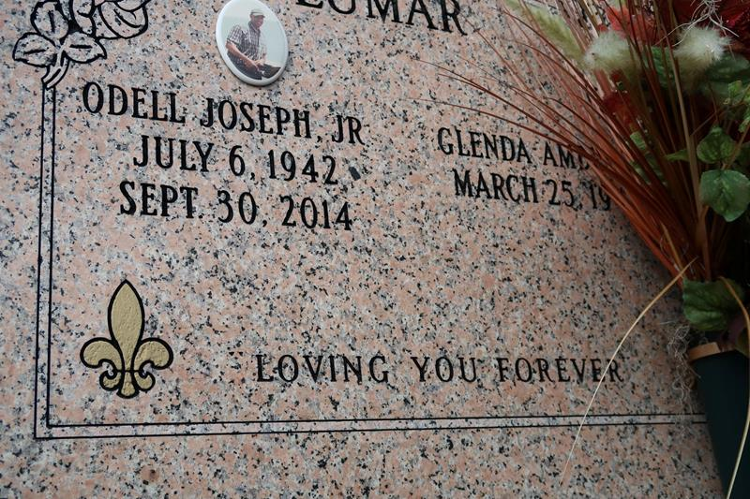

Odell "Boom" Lumar Jr. passed away Tuesday, September 30, 2014, at the age of 72 years old. Son of the late Lucille and Odell Lumar, Sr. Beloved husband of Glenda Ambrose Lumar. Father of Schiwyn (Rev. Carnel) Joseph, Schelita (Anthony) Ealy, Scherell (Dwayne) Sterling, Terrill (Tahena) Lumar, Tresha (Jamie) Bartholomew, and Odell (Toni) Lumar, III. Brother of Marva, Betty, and Adam Lumar and the late Laura Mae Harrison, Carolyn Miller, Albert, Horace, Alvin, and Leonard Lumar. Brother-in-law of Lawrence (Pauline) Ambrose, Jr. and Dolories Lumar. Nephew of Eloise Johnson. Also survived by a host of grandchildren, cousins, nieces, nephews, godchildren, other relatives and friends.
Funeral services will be held at St. James Catholic Church, 6613 Highway 18, St. James, La., Friday, October 10, 2014 for 11:00 a.m. Visitation will be from 9:00 a.m. until time of service. Father Christopher Decker will be officiating. Interment will be at St. James Catholic Church Cemetery, St. James, La. Funeral entrusted to The Baloney Funeral Home, LLC, 1905 W. Airline Highway, Laplace, La., 985-224-8460. Condolences can be expressed at www.baloneyfuneralhome.com.
The New Orleans Advocate, Louisiana
Oct. 6 to Oct. 10, 2014

