Dorothy Mae (Wells) Meggs

May 10, 1923 – June 17, 2004

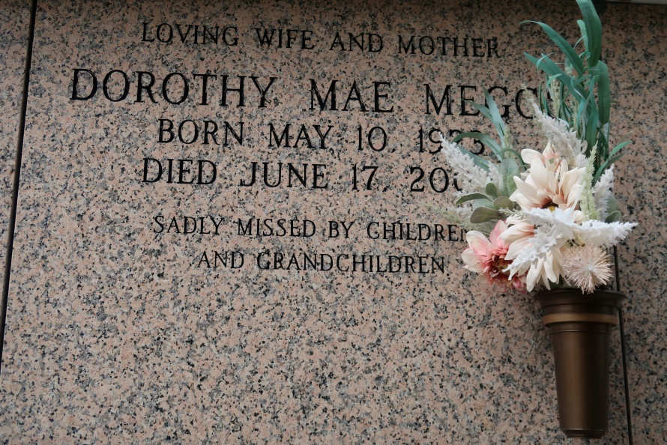

Dorothy Wells (Bessie) Meggs, at St. Elizabeth Hospital in Gonzales, LA at 5:50 P.M. on Thursday, June 17, 2004.

Daughter of the late John Wells and Catherine Miller Wells. Wife of the late Sidney Meggs, Sr. Mother of Carolyn and Sidney Meggs, Jr., Kathy Meggs Kelson, and the late Brenda and Spencer Meggs. Mother-in-law of Osborne Kelson, Sybil and Carol Meggs. Sister of the late Louise, Huey and Ray Wells. Also survived by 10 grandchildren, 8 great grandchildren, numerous nieces, nephews, cousins, other relatives and friends. Age 81.

Visiting at Mt. Calvary Baptist Church, Mt. Calvary Street, St. James, LA on Monday, June 21, 2004 from 9:30 A.M. until religious services at 11:00 A.M. Conducted by the Rev. Samuel Jones. Entombment in St. James Catholic Church Mausoleum in St. James, LA. BRAZIER-WATSON FUNERAL HOME in charge of arrangements.

Published by The Times-Picayune (Baton Rouge, LA)

June 20, 2004.