Raymond "Killa" Melancon
November 29, 1946 - October 19, 2022

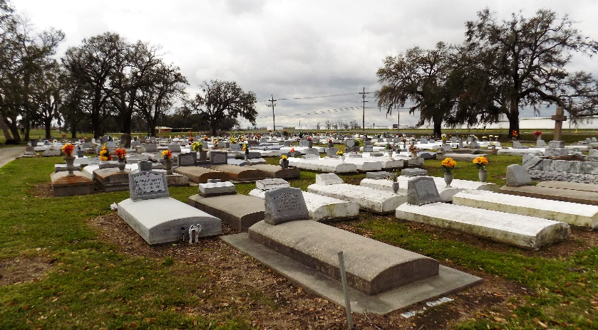

Raymond Melancon, Sr., was born on November 29,1946 in Vacherie, LA to Joseph, Sr. and Flavia Nash Melancon. He was the fifth of twelve children. As a child, then as an adolescent, Raymond shared many happy and fond memories with his parents, siblings, and extended family on St. Joseph’s Plantation. Raymond attended Magnolia High School.
On September 25, 1965, Raymond married Eva Lois Melancon (neé Charles). Four children were born to this loving union: Raymond Paul, Thelonios Germaine, Ariana Marquita, and Kody Joseph Melancon. A dependable and generous provider for his wife and children, Raymond Sr. began his career as machinist at Avondale Shipyards. In 1983, he joined DynMcDermott Petroleum, where he worked as a process operator for over twenty-five years.
As a devoted father, Raymond instilled the values of hard-work and ambition in his children. He was especially proud when his son, Thelonios, became a first-generation college graduate. He was also proud when his youngest child, Kody, made him a ““Morehouse Dad!” He raised his children to view their accomplishments as expressions of their familial pride, yet he also raised them to be humble, reminding them that to whom much is given, much is required.
Later in life, he would rear his grandchildren, especially Kaleb and Seleste, with the same level of devotion and love he had shown his children during their adolescence. After the passing of his wife, he took on a nurturing role: faithfully preparing Sunday and holiday meals; instructing his grandson Kaleb about mechanics, fishing, and good old-fashioned hard work; and being a reliable and selfless source of help for his children and grandchildren.
In his leisure time, Raymond enjoyed cooking for his children and grandchildren. He would call his sister, Mice, often to get the right recipe. He also enjoyed fishing and hunting with his brothers, attending football games with his brother Larry, and spending time with his extended family in Marrero and Houma. An avid card player, he earned the nickname, “Killa.”
Raymond’s surviving loved ones will miss him dearly. They include four children: Raymond, Jr (Tanya), Thelonios (Dawn), Ariana, and Kody Melancon; grandchildren and great-grandchildren: Briale, Bria, Kaleigh, Tori, Jace, Jacob, Kaleb, Seleste, Cale, Khalani, Kaci, and Thaddeus; three siblings: Florence D. Roussell, Larry (Linda), and Steve (Debra) Melancon; an aunt: Eva Mae (Lawerence) Hall; several brothers-in-law and sisters-in-law: Curtis Castle, Ford (Mary) Charles, Robert (Rita) Charles, Lester (Tawanna) Charles, David (Carmel) Charles, Josephine, Rita, Shelia, and Verlyn Melancon and Yvonne (Albert) Smith, Judith (Henry) Jones, Jeanette Nelson, and Denise (Ronald) Gauthreaux; a godson: Ricky Nelson, Jr.; and a host of nephews, nieces, cousins, and friends. He was predeceased by his loving wife; his beloved parents; several siblings: Stella Castle, James, Sr., Joseph Jr., Royal, Roland, Clinton, Sr., Glenn, Sr., and Barry Melancon; and his father-in-law and mother-in-law, Ford Sr. and Luvera Williams Charles.
Relatives and friends are invited to attend a public visitation Wednesday, October 26, 2022, from 5pm-7pm at Treasures of Life Funeral Services, 315 E. Airline Hwy., Gramercy, LA 70052. A Mass of Christian Burial will be held at St. James Catholic Church, 6613 Highway 18, St. James, LA 70086 on Thursday, October 27, 2022, celebrated by Father Matthew McCaughey. Visitation will be from 9:00am until 11:00am. Mass will begin at 11:30am. Recitation of the Holy Rosary will begin at 9:30am. Interment will follow at Our Lady of Peace Catholic Church Cemetery. Final care and professional services have been entrusted to Treasures of Life Funeral Services.

Treasures of Life Funeral Services, Gramercy, Louisiana
October 27, 2022

