Albertha Mary Mitchell

March 18, 1947 – February 10, 2012

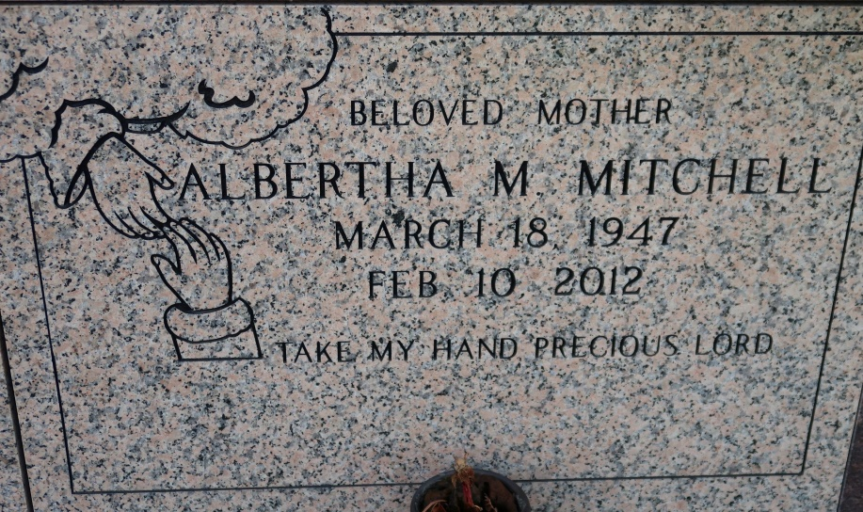

Alberta (sic) Mary "Doom" Mitchell at her residence in St. James, LA, on Friday, Feb. 10, 2012.

Daughter of the late Ozeme Mitchell, Sr., and Alberta Moody Mitchell. Mother and mother in law of Jennifer and Kevin Stewart and Randy and April Thomas. Sister and sister in law of Marie Lewis, Dorothy and Esmond Sheppard, Louise and Hubert Taylor, Leo and Ceola, Roy and Cynthia, Paul and Joann, John and Sandra, Peter, Sr., and Lottie Mae Mitchell and the late Marva Mae LeBoeuf and James and Ozeme Mitchell, Jr. Sister in law also of Lorraine Mitchell and Albert LeBoeuf. Also survived by an aunt Cecile Melbert, godson Theodore Bazille, four grandchildren, numerous nieces, nephews, cousins, other relatives and friends. Age 64.  
 Visiting at New Hope International Center, Vacherie, LA, Wednesday, Feb. 15, 2012 from 9:30 A.M. until religious services at 11:00 A.M. Conducted by Pastor Claudette Aubert. Entombment in St. James Catholic Church Mausoleum, St. James, LA. Brazier-Watson Funeral Home in charge of arrangements.

Times-Picayune, The (New Orleans, LA)

Tuesday, February 14, 2012