James P. Mitchell

August 18, 1944 – January 12, 2012

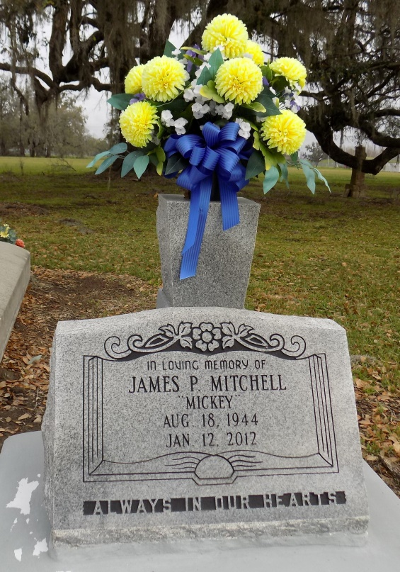

James P. "Mickey" Mitchell at his residence in St. James, LA, at 7:11 p.m., Thursday, January 12, 2012.

Son of the late Ozema Mitchell, Sr. and Alberta Moody Mitchell. Husband of Lorraine Cayette Mitchell. Father of Charetia (Owen) Mumphrey, Rachelle (Dacein), Rondell, and Hyren (Erica) Mitchell. Brother of Marie Lewis, Dorothy (Esmond) Sheppard, Alberta Mitchell, Louise (Hubert) Taylor, Peter (Lottie Mae), Roy (Cynthia), Paul (Joann), John (Sandra), Leo (Ceola) Mitchell and the late Marva Mae LeBoeuf and Ozema Mitchell, Jr. Also Seimon Octave and children, whom he reared. Sister-in-law of Claudette Octave. Stepbrother-in-law of Ernest (Diane) Cayette, aunts, uncles, nieces, nephews, cousins, five grandchildren, godchildren, other relatives and friends. Age 67.

Visiting at the Funeral Home on Tuesday, January 17, 2012 from 3:00 p.m. to 5:00 p.m. and at St. James Catholic church, St. James, LA, Wednesday, January 18, 2012 from 9:30 a.m. until Mass of Christian Burial at 11:00 a.m. Conducted by the Rev. Christopher Decker. Interment in Church Cemetery. Recitation of the Rosary at 10:00 a.m.

BRAZIER-WATSON FUNERAL HOME in charge of arrangements.

The Times-Picayune, New Orleans, Louisiana

January 15 - 17, 2012