John Mitchell

September 6, 1940 – April 20, 2013

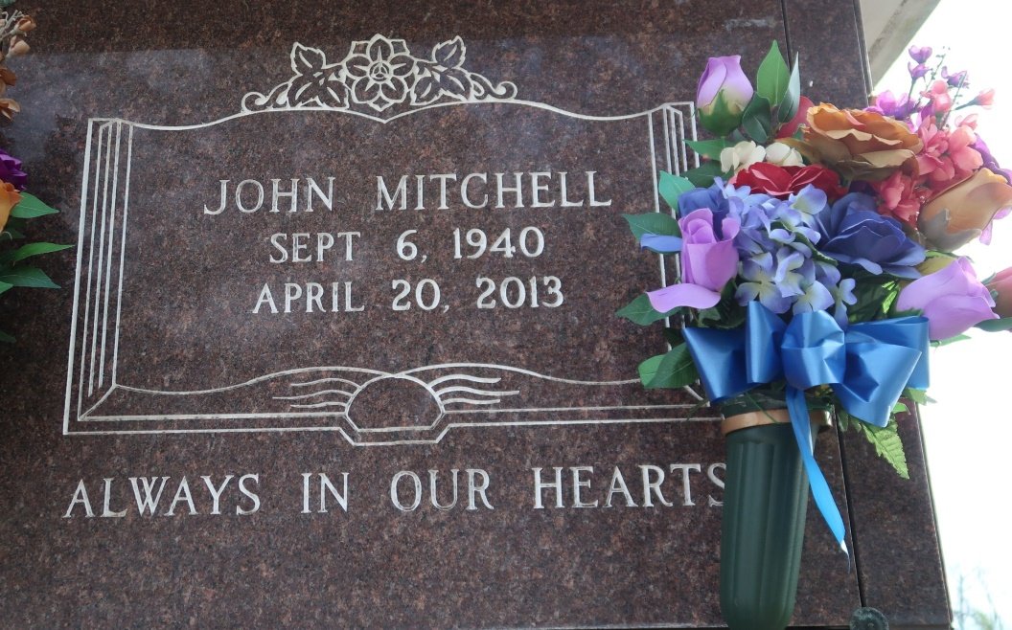

A native of St. James and a resident of Baton Rouge, he died at 3:07 p.m. on Saturday, April 20, 2013 at Our Lady of the Lake Regional Medical Center in Baton Rouge. He was 72.

Visiting at St. James Catholic Church, St. James, on Friday, April 26, 2013 from 9:30 a.m. until Mass of Christian Burial at 11 a.m. conducted by the Rev. Michael Miceli. Entombment in the church mausoleum.

Survived by his wife, Sandra Kinchen Mitchell; his daughters, Roxanne (Troy) Bartholomew, Stacie (Shawn) Mitchell and Erica Kinchen; a son, Eric Kinchen; sisters, Marie Lewis, Dorothy (Esmond) Shepard and Louise (Hubert) Taylor; brothers, Paul (JoAnn) Mitchell, Roy (Cynthia) Mitchell, Leo (Eceola) Mitchell, Peter (Lottie Mae) Mitchell; four grandchildren; a godchild, Cynthia Clifton; mother-in-law, Mamie Cain; 8 sisters-in-law, including Lorraine Mitchell; three brothers-in-law, including Albert LeBeouf; nieces, nephews, cousins, other relatives and friends.

Preceded in death by his parents, Ozeme Mitchell, Sr. and Alberta Moody Mitchell; former wife, Marie Barbara Lemieux Mitchell; two sisters, Albertha Mitchell and Marva Mae LeBeouf; two brothers, Ozeme Mitchell, Jr.   
and James Mitchell; and father-in-law, David Cain.

Brazier-Watson Funeral Home in charge of arrangements. Visit us at www.brazierwatson.com to sign the guestbook.

The Advocate, Baton Rouge, LA; Tuesday, April 23, 2013  
Contributed by Jane Edson