Marie Barbara (Lemieux) Mitchell

October 1, 1941 – March 18, 2000

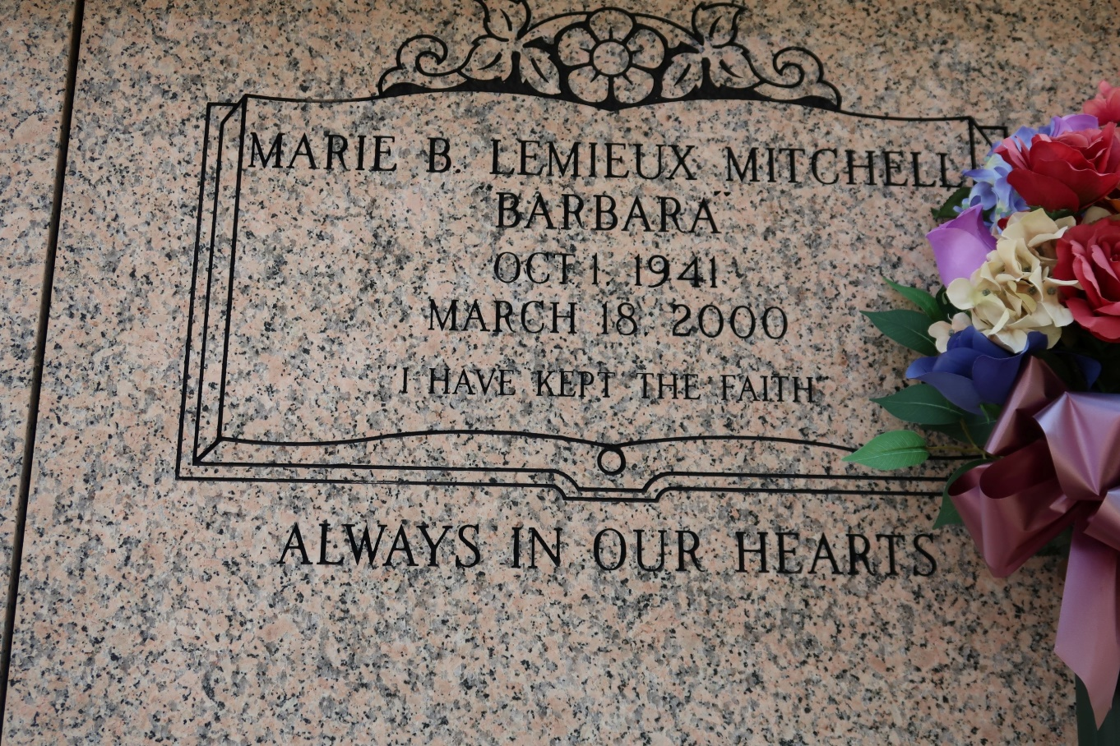

BATON ROUGE - Marie Barbara Mitchell, 58, a native and resident of St.   
James Parish, died March 18. She was the wife of John Mitchell and mother of Roxanne Darensburg and Stacie Mitchell.  
 She was also the daughter of the late Willie and Maude Lemieux and the sister of Doris, Donald, Willie Jr. and Ronald Lemieux. She is also survived by one grandchild.  
 Services are today at 11 a.m. at St. James Catholic Church with entombment in the church mausoleum.

L'Observateur (La Place, LA)

Wednesday, March 22, 2000