Roy Joseph Mitchell Sr.

July 20, 1954 – November 12, 2021

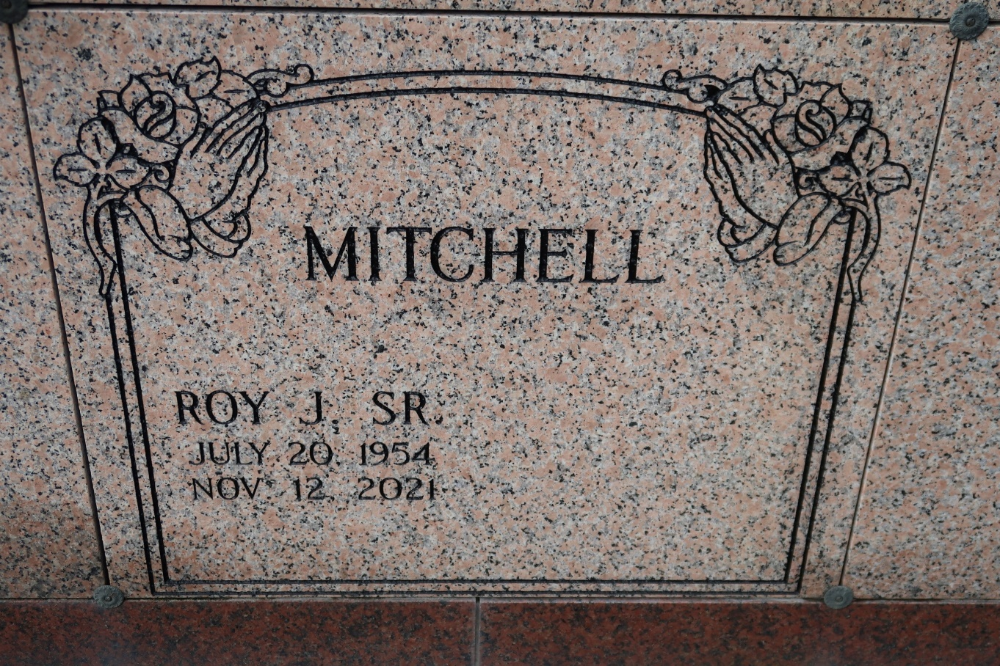

A native and resident of St. James transitioned on Friday, November 12, 2021 at his home at the age of 67. Visiting 9 AM on Saturday, November 20, 2021 at St. James Catholic Church, St. James until Mass of Christian Burial at 11 AM. Entombment in the church mausoleum.

He is survived by his wife of 37 years Cynthia Mayho Mitchell, two daughters Andrea (Durell) Thomas and Shamica Mitchell, a son Roy Mitchell, Jr. (Veronica), stepson Derrick Bell (Yvette), two sisters Marie Lewis and Louise Taylor, three brothers Leo, Paul, and Peter Mitchel, 3 grandchildren, and a host of nieces, nephews, other relatives and friends.

Tributearchive.com