Anatole Louis Monconduit III

September 8, 1922 – April 12, 2005

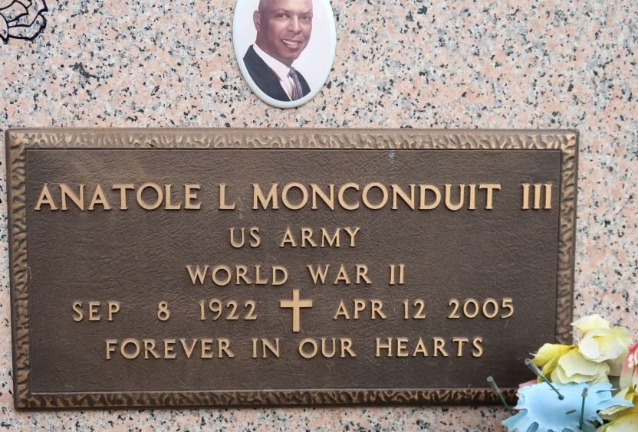

Anatole Louis Monconduit III, a justice of the peace of District 5 in St. James Parish and a retired science teacher at St. James Parish High School, died Tuesday of a heart attack at Baton Rouge General Medical Center. He was 82. Mr. Monconduit was born in New Orleans and lived in St. James. He attended Tuskegee University and graduated from Southern University in Baton Rouge. He was secretary of the Knights of St. Peter Claver Council No. 135. He was a private first class in the Army during World War II.

Survivors include his wife, Doris Figaro Monconduit; four sons, Julius Veazie of New Iberia, Emic Veazie of Gonzales, Owen Monconduit of New Orleans and Anatole Monconduit IV; a daughter, Norwatha Monconduit of New Orleans; a brother, Solis Monconduit of New Orleans; a sister, Natalie Young of Austin, Texas; seven grandchildren; and a great-grandchild.

A Mass will be said today at 11 a.m. at St. James Catholic Church, 6613 Louisiana 18, St. James. Visitation will begin at 8:30 a.m. Burial will be in the church mausoleum. Demby & Son Funeral Home is in charge of arrangements.

Times-Picayune, The (New Orleans, LA)

Saturday, April 16, 2005