Doris (Figaro) Monconduit

February 2, 1929 – November 14, 2008

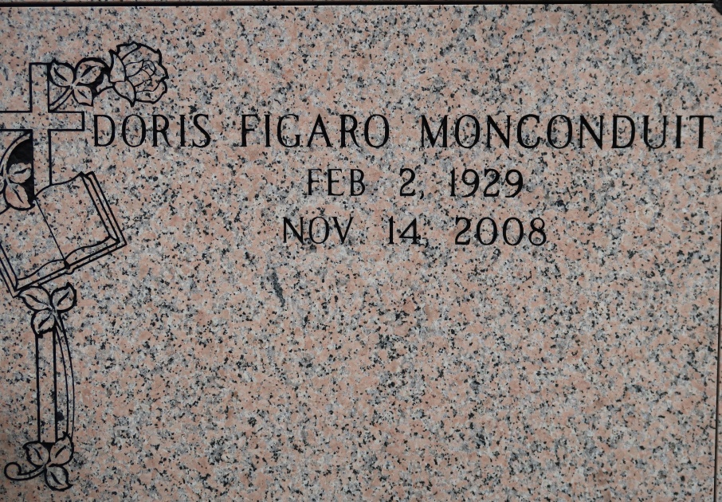

Doris Figaro Monconduit, 79

A retired school teacher and a resident of St. James, she died Friday, Nov. 14, 2008, in Donaldsonville. She was 79 and a native of Lafayette.

Visiting at St. James Catholic Church, 6613 La. 18, St. James, on Saturday, Nov. 22, from 8:30 a.m. until Mass of Christian Burial at 11 a.m., with the Rev. Michael Miceli, celebrant. Entombment in the church mausoleum.

She is survived by a daughter, Norwatha Monconduit; four sons, Julius and Emic Veazie, Anatole "Teddy" IV and Owen Monconduit; seven grandchildren and a great-grandchild. Preceded in death by her husband, Anatole Monconduit III.

She was a member of Knights of Peter Clavier Ladies Auxiliary Court 135, Ascension Parish Retired Educators Association and the Brookstown Benevolent Association, as well as others.

Arrangements by Demby & Son Funeral Home, Donaldsonville.

Advocate, The (Baton Rouge, LA)

Friday, November 21, 2008