Salvador Mouton

Abt 1733 – April 9, 1773

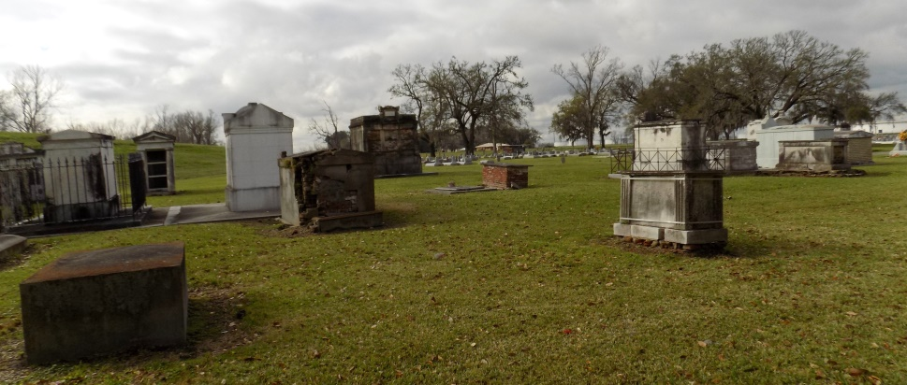

Arrived in Louisiana 1765, age 32, with wife Anne Bastarche, age 34, and two sons--Marin, age 12, and Jean le jeune, age 11. He died at New Orleans hospital and was buried at St-Jacques de Cabahannocer on 9 April 1773 at the age of 40.

<https://www.wikitree.com/wiki/Mouton-157>

Some sources say he was buried at Hospital-des-Pauvres, New Orleans, which translates as Charity Hospital, New Orleans, where he was living at the time of his death, but that cemetery did not exist prior to the 1840s. According to Stephen White’s Dictionnaire Généalogique, Salavdor is buried in the cemetery at the old Catholic Church in St. James.

Anne Bastarache, first wife, died at Cabanocé in c1767  
<https://www.wikitree.com/wiki/Bastarache-191>

Burial records from the collection of unbound pages of the Parish records of St. James Catholic Church, St. James, Louisiana, that are now preserved in the Department of the Archives of the Catholic Diocese of Baton Rouge, list **Mouton, Salvadore** as being buried at St. James Catholic Church in 1773 (p.67).  
  
St. Jacques de Cabhannocer  
The arrival of the Acadians in Louisiana can be dated from the settlement of Salvador Mouton, his nephew, Jean Diogene Mouton, and their families. They are believed to be the first to reach here in the  
mass migration that would eventually bring two-thirds of the survivors of the Acadian exodus to Louisiana.

<http://www.acadian-home.org/acadian-cajun.html>  
  
 Among the new settlers at Cabahannocer were members of a small extended family that would contribute much to the history of South Louisiana.  The Moutons came to Acadia later than most of the families who populated the colony.  In 1703, during the early months of France's second long war with England, Jean Mouton of Marseille, age 14, arrived from France and settled at Port-Royal.  At age 22, in 1711, the year after the British captured Port-Royal from the French, Jean married Marie Girouard of Port-Royal, a member of one of the first families of Acadia.  The next year, they moved to Grand-Pré, where he earned his living as a surgeon and was called Sr. Jean by his contemporaries.  Sons Jean, fils, Jacques, Charles, and Justinien, and daughters Marie-Josèphe and Marguerite were born at Grand-Pré before the family resettled at the even more distant Acadian community of Chignecto in c1725.  Four more children were born to Sr. Jean and Marie at Chignecto:  sons Pierre, Salvator, and Louis, and daughter Anne. The Moutons lived at Chignecto for thirty years and may have been among the dozens of Chignecto families living east of Rivière Missaguash in 1750 who were forced to relocate west of the river, in French-controlled territory.

During the fall of 1755, British forces rounded up the older Mouton sons and their families and deported them along with other Chignecto Acadians to South Carolina.  The three younger sons, Salvator, Louis, and Pierre, somehow escaped the British roundup.  With Salvator's wife, Anne Bastarache, whom he had married at Annapolis Royal in January 1752, and their children, the Mouton brothers fled to the Gulf of St. Lawrence shore and found refuge at Restigouche, at the head of the Baie des Chaleurs.

There, Louis married Marie-Modeste Bastarache, a younger sister of Salvator's wife, in October 1760.  But they did not live there in peace.  The war caught up to them the year of Louis's marriage when, in July, the British attacked the fort at Restigouche with overwhelming force. Pierre died in the fight, and Salvator and Louis fell into the hands of the victorious British, who imprisoned them in Fort Edward, Nova Scotia, at the former Acadian settlement of Pigiguit, for the rest of the war.  Louis's daughter Anne-Charlotte was born in one of the prison compounds in February 1764.  In late 1764 or early 1765, Salvator, Louis, and their families joined hundreds of other Nova Scotia detainees in their exodus to Louisiana.  The Mouton brothers were among the dozens of Acadians who settled at Cabahannocer.  With them was nephew Jean dit Neveu, son of Salvator's and Louis's older brother Jacques, and Neveu's wife Élisabeth Bastarache, whom he had married in Nova Scotia; their daughter Marguerite-Françoise was born at New Orleans on November 20, so Élisabeth had been pregnant on the long voyage down from Halifax.

Salvator's wife Anne died soon after they reached Cabahannocer, and he remarried to fellow Acadian Anne Forest at New Orleans in c1768.  Salvator and Louis's older brother Charles, who had been deported to South Carolina in 1755, reached Louisiana from Martinique during the late 1760s.  Typically, Charles, his wife Anne Comeau, and their son Georges joined his kinsmen at Cabahonnocer, now being called the Acadian Coast.  Salvator died in a New Orleans hospital in April 1773, age 40; he was survived by his wife and three children from his first marriage:  sons Marin, age 20 at the time of his father's death, and Jean, age 19, and daughter Marie-Geneviève, only 8 years old.  A few years after their father died, Marin, Jean, and Marie-Geneviève, along with their cousin Jean dit Neveu and his family, moved to the Attakapas District.  It was there that the Mouton brothers made names for themselves as land  
speculators.

<http://www.acadiansingray.com/Acadians%20of%20LA-history-3.htm>

Contributed by Ryun Mouton (ryun.mouton@gmail.com)