Helen (Bobbler) Nelson

April 27, 1933 – December 12, 2020

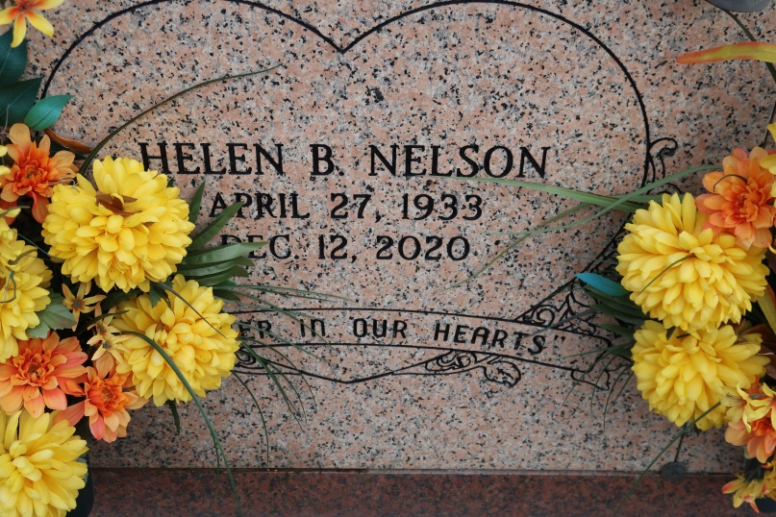

Helen Bobbler Nelson, a native and resident of St. James. She passed away peacefully at her residence at 9:58 pm, Saturday, December 12, 2020. She was 87. A public walk-thru visitation will be held at the Funeral Home, 623 Railroad Avenue, Donaldsonville, Friday, December 18, 2020 from 2 to 4:00 pm. Visiting will continue on Saturday, December 19, 2020 at St. James Catholic Church in St. James, from 10:30 am until Mass of Christian Burial at 11:00 am. Immediate family members only. Entombment in the Church Mausoleum. Masks Must Be Worn At All Times. Survived by daughters, Sandra (Thomas) Lewis, and Malinda Nelson. Adopted daughter, Theresa (Earl) Tassin. Sons, Lionel, Jr., (Elizabeth), Donald (Thelma) Nelson, and Anthony Nelson. Sisters, Adleen Whittington and Joann (Paul) Mitchell. Also numerous grandchildren, great grandchildren, aunts, nieces, nephews, cousins, other relatives and friends. Preceded in death by her parents, Joseph Bobbler, Jr. and Daisy Mitchell Bobbler. Her former husband, Lionel Nelson, Sr. Her sons, Lawrence, Donald, Ronald and Kenneth Nelson. Brother-in-law, Tofield Whittington, Sr. Daughter-in-law, Cynthia Nelson. Brazier-Watson Funeral Home in Charge of Arrangements. Visit us at www.brazierwatson. com to sign our guest book.

The Advocate, Baton Rouge, Louisisana

December 16-19, 2020