Lionel Nelson, Sr.

September 29, 1929 – October 6, 2013

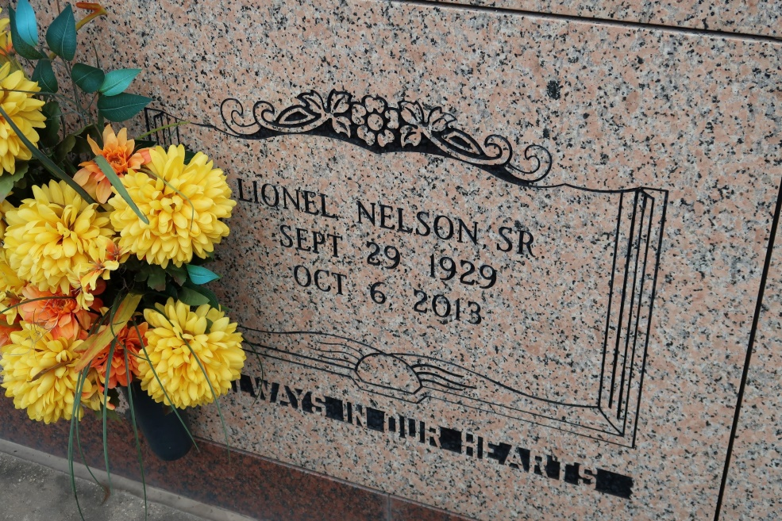

A native and resident of St. James. He died at St. Elizabeth Hospital in Gonzales, at 6:15 p.m. Sunday, Oct. 6, 2013. He was 84.

Visiting at St. James Catholic Church, St. James, Saturday, Oct. 12, 2013, from 10:00 a.m. until Mass of Christian Burial at 12:00 noon, conducted by the Rev. Christopher Decker. Entombment in church mausoleum.

Survived by six daughters and their spouses: Sandra and Thomas Lewis, Malinda Nelson, Edith Pedescleaux, Melanie and Armond Keller, Clettia Wells, and Quentessa and Willie Sensley. Four sons: Rev. Lionel Jr. and Elizabeth Nelson, Donald and Thelma Nelson, Clyde Anthony and Cynthia Nelson, and Leroy Fraizer; stepdaughter, Lynette and husband, Corey Jacobs; stepson: Christopher Pedescleaux; nieces, nephews, cousins, other relatives and friends; and numerous grandchildren and great-grandchildren.

Preceded in death by his parents, Gus Nelson and Estelle Johnson Nelson; a son and his wife, Lawrence and Lynette Nelson; three sisters, Clothia Branch, Louvenia Scott and Hilda Harris; five brothers, Paul Nelson Sr., Victor Nelson Sr., and Norward, Louis and Raymond Nelson.   
 Brazier-Watson Funeral Home in charge of arrangements. Visit www.brazierwatson.com to sign the guestbook.

The Advocate, Baton Rouge, LA; Wednesday, October 9, 2013  
Contributed by Jane Edson