Anna Belle (Chiquet) Nicholas

August 29, 1929 – August 23, 2006

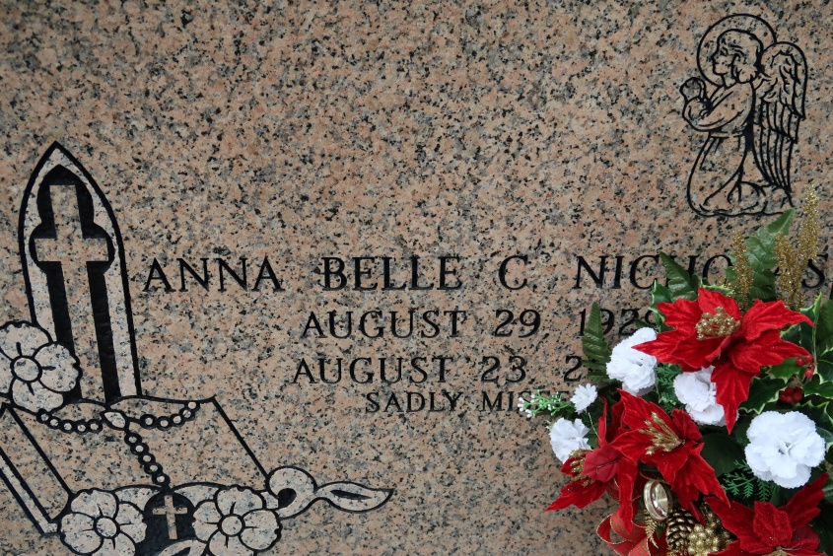

Nicholas, Anna Belle Chiquet

A retired cafeteria manager with Prevost Hospital in Donaldsonville, she died at 8:30 a.m. on Wednesday, Aug. 23, 2006, at her daughter's home in Geismar. She was 76, a resident and native of St. James.

Visiting at St. James Catholic Church on Monday, Aug. 28, from 8 a.m. to 9:50 a.m., with recitation of rosary at 9 a.m. Religious service at the church at 10 a.m., conducted by the Rev. Louis Oubre. Entombment in the church mausoleum.

She is survived by three daughters, Lucretia Nicholas, Charmaine Williams and Nina Nailor; two sisters, Claudette Octave and Lorraine Mitchell; six grandchildren and five great-grandchildren. She was preceded in death by her husband, Eddie Nicholas; and mother, Hattie Chiquet.  
  
 She was a member of the Pride of Brookstown and Rising Sun Societies as   
well as the St. James Catholic Prayer Line. The Baloney Funeral Home LLC of   
Garyville is in charge of arrangements.

Advocate, The (Baton Rouge, LA)

Sunday, August 27, 2006