Edwin Octave Jr.
June 2, 1922 – March 17, 2024

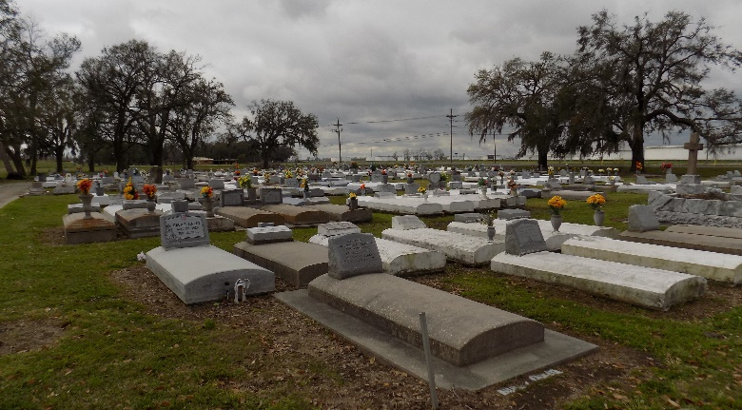

Edwin Octave, Jr. (DuLou, EO,JR), a loving father, grandfather, great-grandfather, great-great grandfather, uncle, cousin and friend on Sunday, March 17, 2024 took his bath, put on his long white robe, bid us goodbye, and boarded that Morning Train. Edwin was born June 2, 1922, to the union of the late Edwin and Clayer Octave, Sr. He was baptized on June 11, 1922, at St. James Catholic Church by the late Rev. J. Barbe’ and has served FAITHFULLY all his life for Over A Century. Not Many people can proudly proclaim this. Our Dad started his service with Father Barbe’ and continued with each Priest through now (in some sort of capacity). On June 17, 1941, Edwin was united in Holy Matrimony to the late Lilly Rose Treaudo, to this union 12 children were born. With this marriage came a new set of parents, the late Ben and Lillie Treauedo. Edwin was the proud parent of 15 children, 7 girls and 8 boys: Barbara, Catherine, Patricia, Rosalin, Nermia, Desiree, La Sandra, Ronald, Randell, Edwin III, Brad, Bryant, Brian, Kevin, and Davis.
Edwin was known by many names, and over his lifetime he wore many hats. One thing many may not know and that is, he was a Civil Rights Activist. During his lifetime, Edwin labored in the fields at Bessie Kay Plantation, drove Sugarcane Trailers for Gravois, worked as a truck driver for Borden’s Dairy, and sold shoes and insurance. In 1981 at the age of 60, he retired after 31 years from Gerhardt’s Inc. in Jefferson, Louisiana. Later in 1985, he embarked on a new career with the Diocese of Baton Rouge, working at his church, St. James Catholic Church in the maintenance department and retired on June 28, 2013, after 32 years. He also is a Veteran of the United States Navy.
He has lived a very active lifestyle and was dedicated and committed to the community and has received many recognitions, which includes but not limited to, being instrumental in bringing to St. James Parish, the First Black Priest, Father Perry which was followed by Father Ladeau and Father Oubre. He was the Honoree for the St. James Parish Government 2012 Older Worker of the Year award, the 2017 Martin Luther King Scholarship Committee Honoree, received the RV Schexnayder Award and served as Chair of St. James Catholic Church Physical Facilities/Cemetery Committee. He received Special recognition from the Knights of Peter Claver Supreme Knights for years of Service, Recipient of the Silver and Gold medals for service at Past National Conventions of the Knights of Peter Claver and was the 2016 recipient of Knights of Peter Claver Cartagena Award, which gave him the title of Sir Knights and an 81 year member of Knights of Peter Claver. He was a member of several organizations just to name a few American Legion 565; Charter Grand Knights of Peter Claver; St. James Court Council #135, where he served as Grand Knights 3rd and 4th Degree; Past Knights of Peter Claver State President – District 2; Official Cross Bearer at the Knights of Peter Claver National Conventions; E. O. Moss Grand Assembly #4 - 4th Degree; Knights of Peter Claver Past Supreme Officer; Past Grand Knights of Columbus Council No. 11857 Charter member; Knights of Columbus - 3rd and 4th degree; Member of the Archbishop Blenk 4th degree Assembly No. 318; Southern University River Parish Booster Club Member; Martin Luther King Scholarship Committee Founding Member; Retired Vacherie Volunteer Fireman; CAP Committee Member; Rising Sun Benevolent Society Financial Secretary; Pride of Brookstown Society Member; St James Catholic Church Usher; Retired Senior Volunteer Program member and a member of St. James High School Football Booster Club. He has been a tireless volunteer worker in many ways for the betterment of his community, church, school, and fellowman.
Edwin leaves to cherish his memories, his children, Barbara Octave, New Orleans, LA; Catherine Emery, Patricia Roussell, Vacherie, LA; Rosalin (Rev. Collins) Trench, Gonzales, LA; Ronald Octave, Vacherie, LA; Randell (RoseMary) Octave, Baton Rouge, LA; Nermia Butler, Edwin (Betsy) Octave, III, Brad (Betty) Octave, Vacherie, LA; Bryant (Patricia) Octave, Waco, TX; Brian Octave, Gonzales, LA; Kevin (Adrianne) Octave, Desiree Octave, Vacherie, LA; Davis (Roma) Lumar Edgard, LA; and LaSandra (Terrell) Wilson Hahnville, LA, 53 grandchildren, 132 great-grandchildren, 81 great-great-grandchildren, 2 sisters-in-law: Ora Lee Treaudo, New Orleans, LA: Brenda Treaudo, Vacherie LA; 1 daughter-in-law Marcella Octave, Vacherie, LA; 4 Goddaughters: Irma Varner, New York, NY; Bonita Bazile, New Orleans, LA; Demica Williams, Hahnville, LA; Carmella Ellis, Destrehan, LA., and a host of cousins, nieces, nephews, friends, and associates.
He was preceded in death by his wife, Lilly Rose Octave; parents Edwin and Clayer Octave, Sr.; father and mother in-law, Ben and Lillie Treaudo; 4 grandsons, Kevin Emery, Wade Roussell, Lamar Trench and Brandon Joseph; 2 sisters Dorothy Wells and Eunice (James) Roberts, one son-in-law Robert Emery, Sr. and 26 sisters and brothers in law.
A public visitation will be held on Sunday, March 24, 2024, at Treasures of Life Funeral Services, 315 East Airline Hwy., Gramercy, LA 70052 from 6PM-8PM. Relatives and Friends of the family, and members of St. James Catholic Church, all neighboring churches near and far, Knights of Peter Claver St. James Court Council # 135, E O Moss Grand Assembly # 4, Knights of Columbus 4 th Degree, American Legion Post 565, Vacherie Volunteer Fire Department #1, are invited to attend the Celebration of Edwin’s Life and Legacy on Monday, March 25, 2024 at 11:00AM at St. James Catholic Church, 6613 LA Highway 18, St. James Louisiana. Reverend Mike O’Rourke, Celebrant. The viewing will begin at 8:30AM and Rosary at 9:00AM. Entombment at St. James Catholic Church Cemetery.

Treasures of Life Funeral Services, Gramercy, Louisiana
March 26, 2024

