Lansing Jude Octave
August 17, 1969 – June 9, 2024

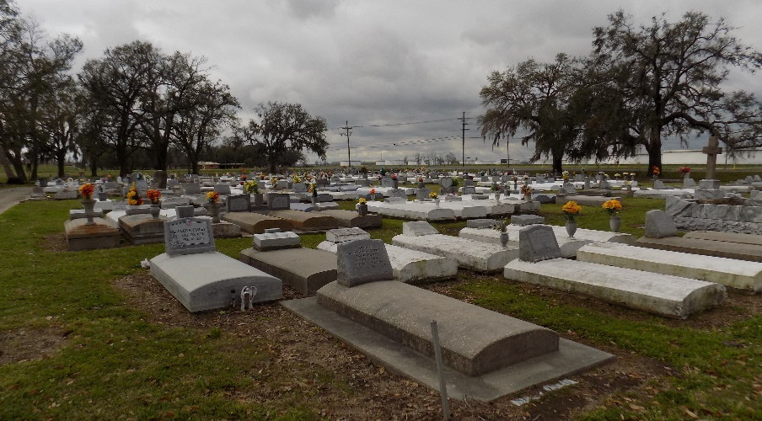

Lansing Jude Octave, 54, native of St. James (Welcome) and resident of Vacherie, Louisiana: A Life Remembered with Love and Passion! Lansing, affectionately known as “Lance,” “Big Luther,” and “Unc”, departed this life tragically on Sunday, June 9, 2024. Born amidst the turmoil of Hurricane Camille on August 17, 1969, to Willis A. Octave, Sr. and Regina (Oubre) Octave, of St. James.
Lansing was spoiled by his siblings: Kimball, Karisue, Billy, and his younger brother Shannon looked up to him. Lansing’s life is marked by his indomitable spirit and loving nature (his smile and unique laughter). He met no stranger. Baptized by Christian Faith at St. James Catholic Church. Lansing loved his family. He married the love of his life and his senior prom date, Michelle Nailor. He often would joke about their simple date at McDonald’s that sparked a lifelong romance for 28 years. He would often state that ‘he was the prize’ of the marriage! As a couple, they enjoyed many wonderful times together, traveling, dancing and riding their motorcycles. Together, they are proud parents of two beautiful and talented daughters: Payton and Ashley. Lansing's dedication to his family was evident in everything he did; his daughters were his greatest motivation and the reason behind his unwavering hard work. Payton and Ashley were the jewels in his eyes and there was nothing he wouldn’t do for them. His daughters would get anything out of him.
An avid sportsman, renowned at the age of 10, for his powerful homerun swing (recorded as a hit of over 400 feet) during a little league baseball game in Donaldsonville. This home run hit was submitted to be published in the Babe Ruth Foundation’s record. Not only was Lansing an outstanding baseball athlete, his tenacity as a defensive tackle for the “Mighty Wildcats” football team at St. James High School earned him the honor of being an All-Star Athlete, leading to a scholarship offer from Prairie View A & M University. Lance was a proud graduate of St. James High Class of 1987. After his collegiate football career, Lance returned home and obtained a P-Tech certification from Louisiana Technical Institute. This achievement paved the way for a distinguished 32-year tenure at Occidental Chemical Corporation in Convent, where he rose to the position of Operations Supervisor. He was diligently working towards his five-year retirement plan and was dedicated to mentoring others to be successful as well. Lance was well respected and loved at Oxy Chem.
Lance enjoyed life: Known for riding in “old school” cars with the top down, playing loud music and attending various car and bike shows was one of his weekend pastimes. On Friday nights, you would see him and his UTR posse in the stadium cheering for St. James High School Mighty Wildcats Football Team. He enjoyed watching his other favorite sports teams: New Orleans Saints, LSU Football, and LSU Women’s Basketball. Another pastime was playing cards with his family, a tradition that he always looked forward to, losing money at Jubilee Casino and annual gatherings with the “BustUp Krewe”. From youth to adulthood Lance loved riding all types of motorcycles; then exclusively, he only rode “Harley” motorcycles. Big Luther joined the brotherhood of the Street Hogs Nation - New Orleans, and was a brother of Magnolia Lodge #2.
Lansing loved life and his family, he leaves to cherish his memories through his wife, Michelle Nailor Octave, daughters: Payton and Ashley Octave; siblings: Wendell Octave, Sr., Karisue (Ricky) Nelson, Willis (Daphne) Octave, Jr., and Shannon (Shantel) Octave; nephew/son, Wendell (Ariel) Octave Jr.; mother-in-law, Grace D. Nailor; sisters-in-law: Rita Dumas, Patricia Nailor Davis, Esther (Lazin) Grow, Caroline Oglesby, Johonna Nailor, Angela (Joe) Malarcher, Dwanda Adams, Cynthia Joseph; brothers-in-law: Charles (Nina) Nailor Sr., Claudell Nailor, James Nailor, Jr., Gregory Clark, Jr. and Ronald Oglesby II: Godchildren: Jamie (Dencil) Johnson, Jerinae Simoneaux, Brandi Clark; a host of nieces, nephews, other relatives and friends.
Preceded in death by his parents: Willis A. Octave, Sr. and Regina Oubre Octave; his father-in-law, James T. Nailor, Sr., his sister-in-law, JeNaiya Nailor Clark and nephew Nevelle Grow. Lansing Jude Octave’s legacy is one of love, dedication, and an unwavering passion for life. His memory will be cherished by all who know him.
A gathering of family and friends will be held on Friday, June 21, 2024 from 5-7pm at Treasures of Life Center for Life Funeral Services, 315 E. Airline Hwy, Gramercy, La 70052. A Mass of Christian Burial will be held on Saturday, June 22, 2024 at St. James Catholic Church, 6613 La-18, St. James, La 70086. Visitation begins for 8:00am with Mass to follow for 10:30am. Entombment at St. James Catholic Church cemetery. Fr. Mike O’Rourke, celebrant.

Treasures of Life Center for Life Funeral Services, Gramercy, Louisiana

