Jake J. Pizzolato, Jr.

October 1, 1926 – March 18, 1995

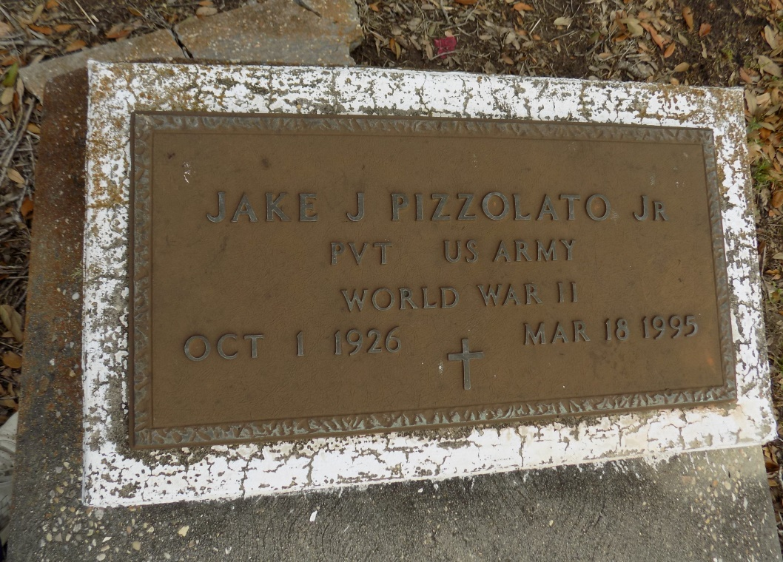

Died 6:45 p.m. Saturday, March 18, 1995, at Veterans Administration Medical Center, New Orleans. He was 68, a native and resident of Donaldsonville.

Visiting at Wilbert Funeral Home, Plaquemine, 5 to 9 p.m. Tuesday. Visiting at the funeral home 8 a.m. until religious services at 10:30 a.m. Wednesday, conducted by Father Jerome Dugas. Graveside services at St. James Catholic Church Cemetery, St. James, at 11:30 a.m. Wednesday.

Preceded in death by wife, Julia Theresa Tabor Pizzolato.

The Advocate, Baton Rouge, LA

Tuesday, March 21, 1995