Ralph Joseph Plaisance

May 27, 1929 – January 25, 2001

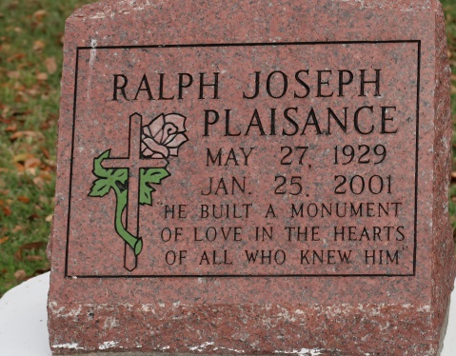

ST. JAMES - Ralph Joseph Plaisance, 71, a native of New Orleans and resident of Vacherie for 35 years, died Jan. 25. He was the father of Karen Freeman-Day, Sandra Campbell and Michael and Dale Plaisance. He was a U.S. Army veteran, retired principal of Sixth Ward Elementary School in Vacherie and member of the Martin Luther King Scholarship Organization and Louisiana Association of School Executives.   
 Services are today at 11 a.m. at St. James Catholic Church, St. James, with interment at the church cemetery. Visitation starts at 9 a.m.

L'Observateur, LaPlace, LA

February 4, 2001

\*\*\*\*\*

Ralph Joseph Plaisance, a former principal and educator at Sixth Ward Elementary School in Vacherie, died Jan. 25 of undetermined causes at Thibodaux Regional Hospital. He was 71. Mr. Plaisance was born in New Orleans and lived in Vacherie for 35 years. He received a bachelor of science degree in elementary education from Leland College and a master's degree in education from Southern University. Mr. Plaisance was affiliated with the annual Mother's Day Program, J. K. Haynes Foundation in Thibodaux, the Kingsman Club, Men's Day Program, the Martin Luther King Scholarship Organization and the Louisiana Association of School Executives. He served as an Army private in the Korean War. Mr. Plaisance taught continuing education programs for adults for many years. He was a teacher and principal for more than 46 years, and after retiring from the St. James Parish public school system. He became a teacher at St. James Parish Youth Center, where he taught at-risk children.

Survivors include two sons, Dale Plaisance of New Orleans and Michael Plaisance of Los Angeles; two daughters, Karen Freeman and Sandra Campbell, both of Atlanta; and five grandchildren.   
 A Mass will be said Saturday at 11 a.m. at St. James Catholic Church in St. James. Burial will be in the church cemetery. Baloney Funeral Home is in charge of the arrangements.

Times-Picayune, The (New Orleans, LA)

Friday, February 2, 2001  
Contributed by Jane Edson