Stephan Anthony Poirrier

December 4, 1945 – August 19, 2018

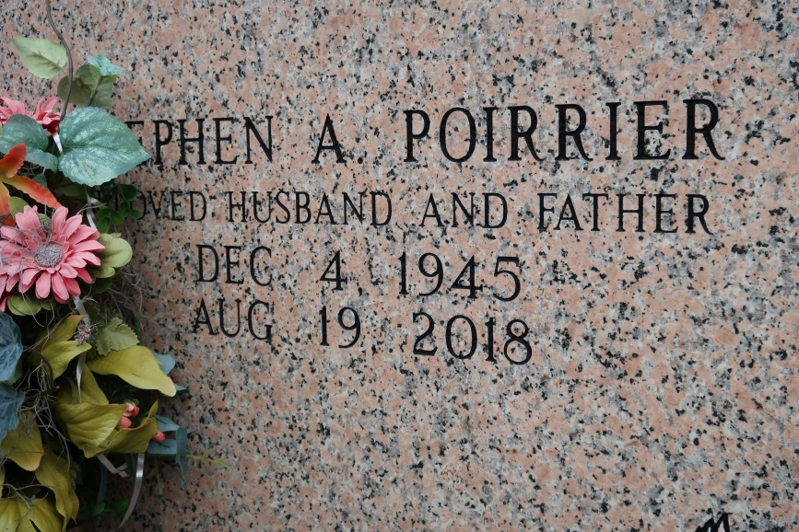

Stephen A. "Skinny Minny" Poirrier was born on December 4, 1945 and was called to his eternal home on August 19, 2018. He was a native and lifelong resident of St. James, Louisiana. As a skilled carpenter, he has left his mark throughout our parish and nearby communities; and let's not forget the selling of those delicious homegrown tomatoes. He will always be remembered for his wit and charm; and it will all be greatly missed.

He is survived by his loving and devoted wife of 50 years, Clair R. Poirrier; sons, Stephen A. Poirrier Jr. (Yvette) and Robin J. Poirrier (Susan); daughter, Leticia Poirrier Doyle (J.T.); 6 grandchildren, Trey Poirrier, Ashley Poirrier, Stephen A. Poirrier III, Cameryn Poirrier, Paul Roth and Daxton Doyle; two great grandchildren, Avery Williams and Kade Michael Poirrier; sisters, Donna Glaviana and Annalynn Giroir; brothers, Rene L. Poirrier III and Byron D. Poirrier.

He is preceded in death by his parents, Rene Jr. and Dolores Barrios Poirier.

A visitation in his honor will be held on Wednesday, August 22, 2018 at St. James Catholic Church from 9am until Mass of Christian Burial at 11am. Interment to follow in the St. James Mausoleum.

Ourso Funeral Home, Donaldsonville, LA