Grace (Mumphrey) Reynolds

March 9, 1918 – April 23, 2017

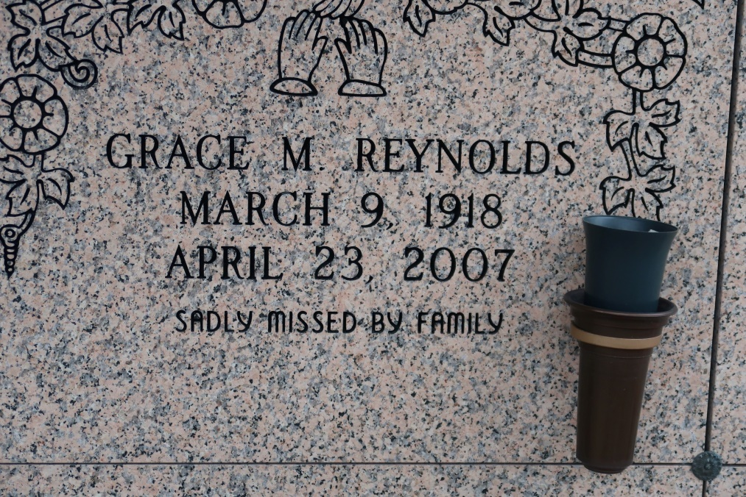

A retired certified nursing assistant, she died Monday, April 23, 2007, at her home in Donaldsonville. She was 89, a native of St. James and a former resident of Oakland, Calif.

Visiting at Mount Triumph Baptist Church, La. 1 South, Donaldsonville, on Saturday, April 28, from 8 a.m. until religious service at 10 a.m., conducted by the Rev. Carnell Joseph. Entombment in St. James Catholic Church Mausoleum, St. James.

She is survived by a sister, Ida Nicholas of St. James; two nephews, Lynn Nicholas and spouse Dianne of St. James and Donald Joseph and spouse Barbara of Killeen, Texas; two great-nephews, Clyde Weber Jr. of Reserve and Dontrell Nicholas of Dallas; two great-nieces, Carla Barnes and spouse Jerrad of Reserve and Danitra Nicholas of Dallas; and a host of other relatives and friends.

She was preceded in death by her parents, Jack and Josephine Mumphrey; husband, Walter Reynolds; four sisters, Irene Mumphrey, Catherine Brooks, Josephine Joseph and Ruth Smith;and niece, Carolyn Weber.

Arrangements entrusted to Williams ***&*** Southall Funeral Home, Donaldsonville.

The Advocate, Baton Rouge, LA

April 27, 2007