Roger Joan Rousseau

Abt. 1931 – November 30, 2000

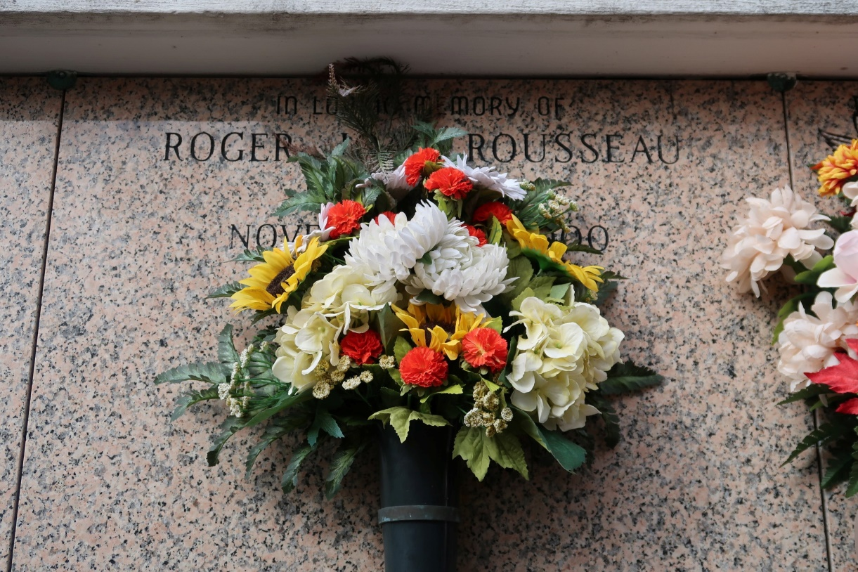

ST. JAMES - Roger Joan Rousseau, 61, a native of Paincourtville and resident of St. James, died Nov. 30. He was the husband of Gertrude Falgoust Rousseau and father of Lynette Martinez and Kevin Rousseau. He was also the son of the late Roy and Agnes Blanchard Rousseau and brother of Eveline Alleman, Agnes Hymel and Stephen, Eric, Irwin, Roy and the late Adele Rousseau. He is also survived by five grandchildren. He was an employee of St. James Sugar Co-Op.   
 Services are today at 11 a.m. at St. James Catholic Church, St. James, with interment at the church mausoleum. Visitation starts at 8 a.m.

L'Observateur, LaPlace, LA

December 2, 2000