Voncia Renee (Winchester) Shepherd
January 24, 1980 – April 20, 2024

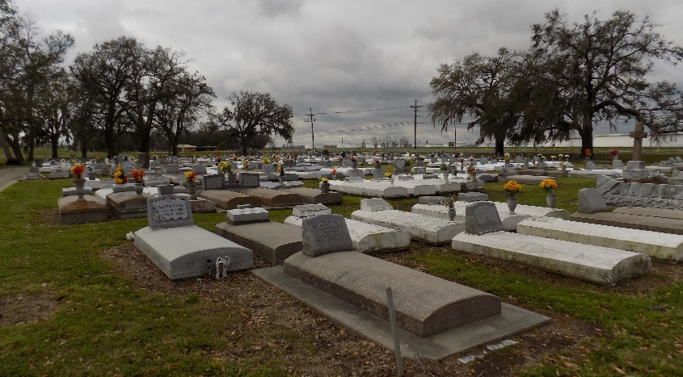

Voncia "Renee" Winchester-Shepherd was born January 24, 1980 in New Orleans, LA to Florence V. Winchester and William "Bill" Russell. She was a 1997 graduate of McDonald 35 High School where she was a member of the Modern Dance Team. She was also a band member, playing the clarinet. Von's greatest joy was her daughter "Jade". She loved her immeasurably and encouraged her to always do her best in all of her endeavors. They shared quality time laughing, going to special events and dancing... dancing... dancing. STRANGERS...she's never met one. Von was one of the kindest person you could ever meet.
As a native of New Orleans, a national choreographer with U.S. Congressional recognition, and fitness professional, V. Renee Shepherd was a creative servant who used artistic expression to impact and heal her community. Shepherd's journey, with 20+ years of experience as a lead choreographer and dancer, has performed (under the direction of Stacy J., Unified Praise Dance Company) on the Stellar Awards (9 years), Dove Awards, Bobby Jones Gospel, and tributes to Civil Rights leaders and Congressman John Lewis and Rev. Jesse Jackson. As a lead choreographer at Windsor Village United Methodist Church, she cultivated the corporation SHE Power, LLC and the organization G.L.A.M. (Girls Learning to Achieve More) created to empower young women and provide resources for the community through the arts.
After surviving Triple Negative breast cancer (2013), V. Renee Shepherd would still go on to teach dance in various sectors. With the increased awareness of the importance of healthy living, Shepherd aligned her platform and her purpose to encourage self-love, healing, and stress relieving principles. She enforced this new level of thinking by instituting deep stretch classes (NASM and ASFA licensed stretch instructor), and heels dance classes named Mirror Envy through the fitness company V. Power Fit. She used her dance experience and fitness expertise to create Core Fit Therapy, LLC (stretch and recovery company) to help rehab/heal issues of the core and lower back areas of the body. The common thread of Shepherd's journey has been spirituality, healing and creativity.
With her daughter (Jade) in college, Voncia embraced higher heights. God welcomed His angel, Voncia to her heavenly home on April 20, 2024. She is preceded in death by both paternal and maternal grandparents. She leaves to cherish her memories her devoted daughter and best friend, Jade A. Stewart; loving parents, Florence V. Winchester and William "Bill" Russell; special aunt and second mom, Sylvia W. Tankerson; awesome Godparents, Paul Jeston Winchester and Felicia Whittington; siblings, Jomal Russell (Tammy), Veronica Russell and Nia Russell; caring Godson, Tre' A. Valentine; and a host of aunts, uncles, cousins, classmates and friends.
A Mass of Christian burial will be held on Saturday, April 27, 2024, at St. James Catholic Church, 6613 LA-18, Saint James, LA 70086. (VISITATION PERIOD FOR 1HOUR) from 11am-12pm only. Tributes and Reflections(12-12:50pm) Mass to follow at 1PM. Interment at St. James Catholic Church Cemetery.

Treasures of Life Funeral Services, Gramercy, LA
April 28, 2024

