Julien J. Sims

April 29, 1937 – April 24, 2012

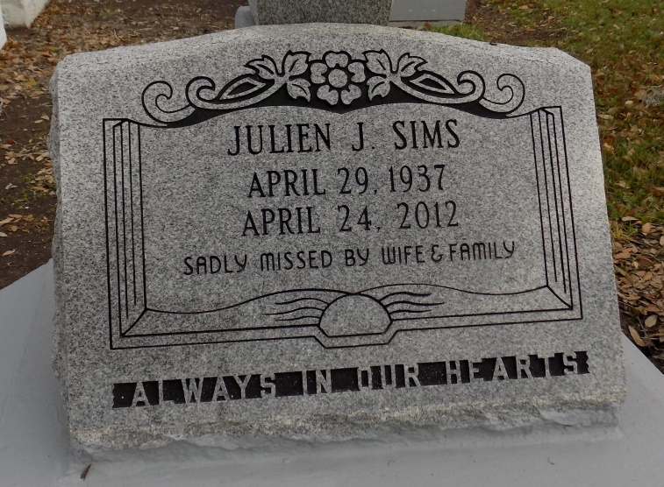

**Julian Or Red Sims, 74**

A retired employee with International Longshoreman Association Local 300, he died at 11:05 p.m. Tuesday, April 24, 2012, at his residence in Donaldsonville. He was 74 and a native of New Orleans.

Recitation of the Rosary will begin at 8:30 a.m. Saturday, April 28, at St. Catherine of Siena Catholic Church, Donaldsonville, followed by visitation. Mass of Christian Burial at the church at 11 a.m. Saturday, with Rev. Ayo E. Efodigbue, celebrant, and Deacon Edward Gauthreaux. Interment in St. James Catholic Church Cemetery, St. James.

Survived by his wife, Laura Joseph Sims; two daughters, Yolanda and Valerie; son, Timothy Sims, Sr. and his wife, Kutee; brother, Louis Chapman and his wife, Joyce; and 7 grandchildren. Preceded in death by his parents, Walter and Eva Sims; and brothers, Alvin Robinson, Roy Sims and Alladain Sims.

Demby & Son Funeral Home, Donaldsonville, in charge of arrangements (225) 473-9534. Please sign the guestbook at [www.dembyandson.com](http://www.dembyandson.com).

Advocate, The (Baton Rouge, LA)

Friday, April 27, 2012