Clinton Sutherland
January 31, 1948 – January 1, 2024

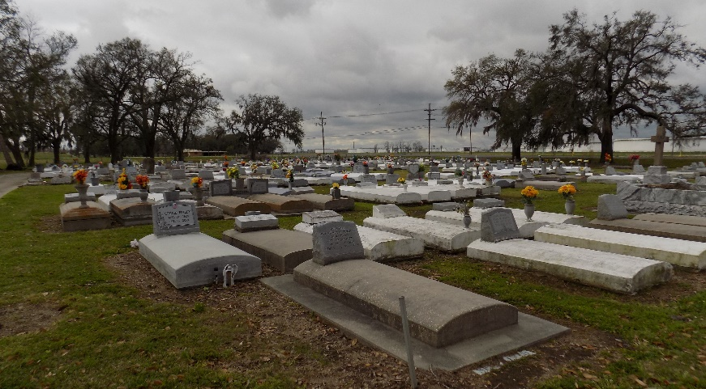

Clinton “Butch” Sutherland, a native of Saint James, Louisiana was born on January 31, 1948. He was born to Clinton Sutherland, Sr., and Marline Ferchaud- Sutherland. Clinton was a resident of Vacherie, Louisiana. He peacefully departed this world on January 1, 2024, at the age of 75. “Butch” married the love of his life, Elaine Jones and to this union, four children were born: Clinton “Nuchey” Sutherland, III (Vacherie, La), LaTasha Sutherland- Geason (Terrence), (Addis, La), Ryan Sutherland and Nicolette Sutherland (both of Vacherie, La). Clinton attended Magnolia High School. He was a retired Sandblaster/ Painter and Truck Driver. He formerly worked at Avondale Shipyard, Lajet, Eugene Gravois Services, Truckers Express and retired from LoneStar Transportation. “Butch” loved spending time with family, cooking, gardening, fishing, hunting, making jokes, taking care of his family, and sitting on his porch while talking to friends and family.
He leaves to cherish his fondest memories to his children: Clinton “Nuchey” Sutherland III, LaTasha (Terrence) Sutherland-Geason, Ryan Sutherland and Nicolette Sutherland; grandchildren: Ellayna Sutherland, Tyler Williams, Ni’Lasia Sutherland, Terren Geason, D’Earen Sutherland, Quan Sutherland, Tren Geason and Xoy Mitchell; great-grandchildren: Kacey, Kaztyn, Kross, Emerie, Kalani and Kaina; siblings: Zedel (Harry) Oubre of Vacherie, LA, Eugene (Marilyn) Sutherland of Saint James, LA, Gerry Sutherland of Donaldsonville, LA, Herman (Charlene) Sutherland of Donaldsonville, LA, Mathilda Barnes, Thaddeus (Laura) Sutherland, both of Vacherie, LA; devoted brother-in-law: Brice (Melissa) Jones of Rowlett, TX.; sisters-in law: Andrea Jones of Waggaman, LA, Wendy Jones of Vacherie, LA, Clarise Oubre of Maryland, and Cynthia Jones of Houma, LA; Godchild: Alex “Bojack” Ferchaud, Jr.; and a host of nieces, nephews, other relatives, and friends.
He is preceded in death by his wife: Elaine Jones-Sutherland; father: Clinton Sutherland, Sr.; mother: Marline Ferchaud-Sutherland; in-laws: Alfred Sr. and Rita Jones; siblings: Joyce Sutherland-Geason, Allen Sutherland and Tyrone Sutherland; brothers-in-law: Alfred, Cornel, Kenneth Jones and Meldon Borne Sr.; sisters-in-law: Carla, Connie and Carol Jones, Stephanie Frye, Pam Brown and Cindy Sutherland; nephews: Mark Jones and Randy Geason; great-nephew: Tylen Oubre; and great-niece Khalei Borne.
A Mass of Christian Burial will be held on Saturday, January 13, 2024, at St. James Catholic Church, 6613 LA-18, Saint James, LA 70086. Visitation will begin at 9AM, with Mass to follow at 11AM. Father Michael O’Rourke, celebrant. Interment at St. James Catholic Church Cemetery.

Treasures of Life Funeral Services, Gramercy, Louisiana
January 15, 2024

