Melvin Sutherland

March 14, 1947 – March 30, 2020

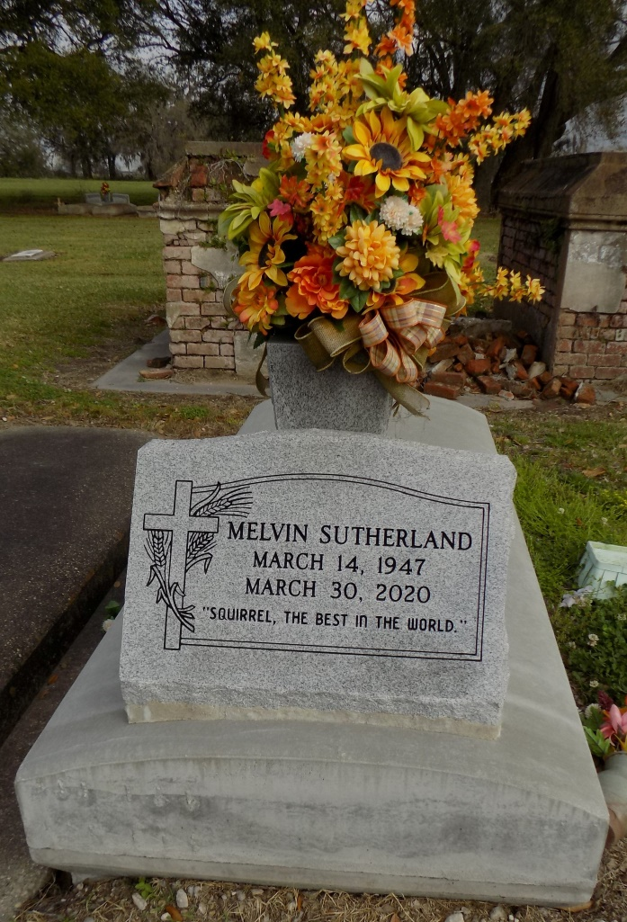

Melvin Sutherland, 73 years old, of Saint James, LA, was granted his angel wings on March 30, 2020. Melvin was born March 14, 1947 in New Orleans, LA to Adam and Enzerbell Southerland. On January 24, 1970, he married his high school sweetheart, Pastor Rita Geason Sutherland. During their 50 year marriage, they were blessed with 4 children (Melanie Winchester, Malana Sutherland, Melvin Sutherland, Jr., and Megan Joseph).

Melvin was survived by his beloved family; wife, Pastor Rita Sutherland, of St. James, LA; 3 daughters, Melanie (Brian) Winchester of Laplace, LA, Malana Sutherland of Sorrento, LA, Megan (Marlon) Joseph of Houston, TX; 1 son, Melvin Sutherland, Jr. of St. James, LA; 2 grandchildren, Brejean and Brian Winchester, Jr.; 1 great grandson, Blaise Winchester; 2 sisters, Gloria Smith of St. James, LA, and Delores Lumar of St. James, LA; 1 brother, Adam Southerland, Jr of Baton Rouge, LA and a host of nieces, nephews, other relatives, and friends.

Melvin was preceded in death by his beloved mother and father Adam Sr. and Enzerbell Sutherland, and sister, Enzerbell Lumar.

Due to the current health crisis, a private gravesite celebration will be held on Saturday, April 4, 2020 at St. James Catholic Church Cemetery. A memorial will be held at a later date. In lieu of flowers and food for repast, donations may be sent to: 5234 Barras Street, St. James, LA 70086. Bardell's Mortuary of Mt. Airy, LA in charge. Information: (985) 535-6837.

The Times-Picayune, New Orleans, Louisiana

April 1 - 4, 2020