John G. Tregre

October 6, 1925 – January 2, 2016

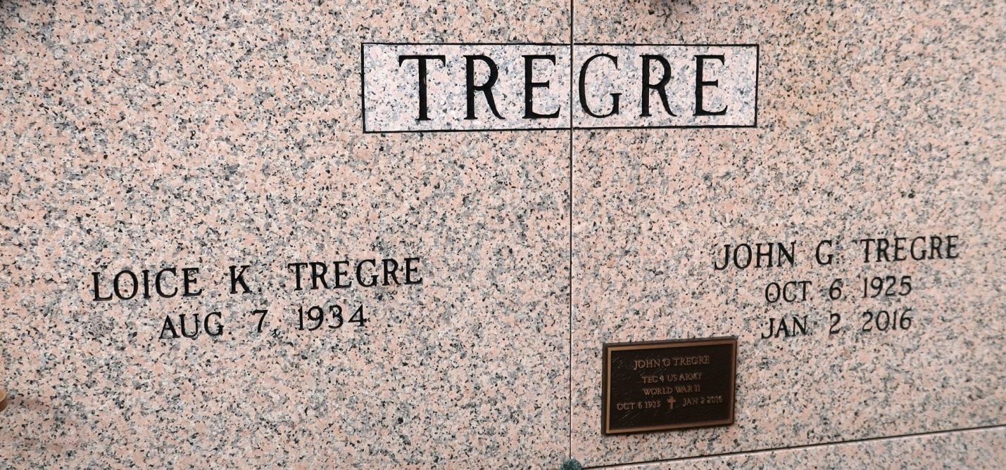

John G. Tregre died peacefully at the age of 90 at home surrounded by family on Saturday, January 2, 2016. He was born and resided in St. James. John was a Veteran of the United States Army. He married his beloved wife, Loice K. Tregre on February 19, 1955.

John is survived by his wife; two daughters and sons-in-law, Peggy T. and Andrew Frey and Mary Kay and Tim Bourgeois. He has five grandkids, Eric Bourgeois and wife, Allison, Scott Bourgeois, Matthew Bourgeois, Samantha Frey, who were the pride and joy of his life. Preceded in death by his grandson, A.J. Frey; parents, Zulma Tassin and Maurice Tregre; grandparents, John and Anna Tregre and Laura and Eli Tassin; one sister, Therese Tregre; and one brother, Maurice Tregre Jr.

Relatives and friends are invited to attend visitation on Tuesday, January 5, 2016, at 9:00 a.m. until Mass of Christian Burial at 11:00 a.m. at St. James Catholic Church in St. James, La. Entombment to follow in church mausoleum. Arrangements by Ourso Funeral Home in Donaldsonville. In lieu of flowers, family request memorial donations be made to St. James Parish ARC. Pallbearers will be Andrew Frey, Tim Bourgeois, Eric Bourgeois, Scott Bourgeois, Matthew Bourgeois, and Samantha Frey. To offer condolences to the family, please visit [www.oursodonaldsonville.com.](http://www.oursodonaldsonville.com/)

The Advocate, Baton Rouge, Louisiana

January 3 -5, 2016