Marie Rose Ann (Favorite) Washington

May 3, 1957 – September 5, 2016

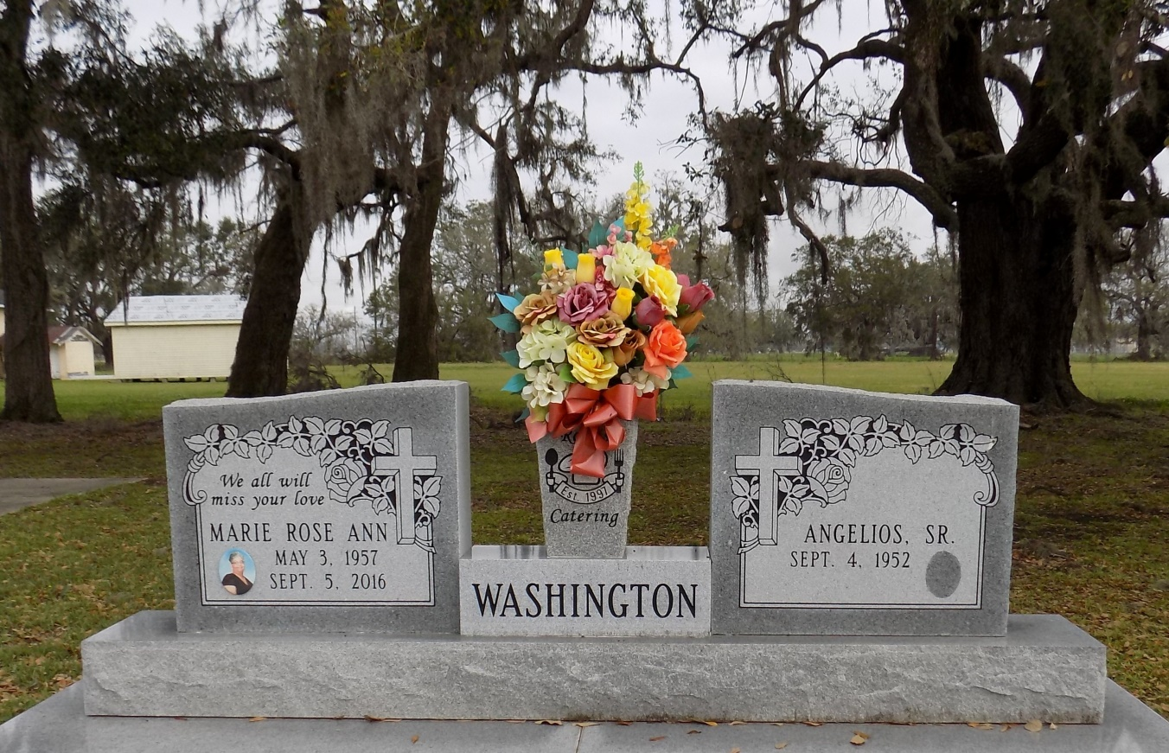

A native and resident of St. James. She passed away at 12:39 a.m., Monday, September 5, 2016 at St. Elizabeth Hospital in Gonzales. She and her husband were the Owners of Rose's Reception Hall in St. James. She was 59.

Visiting at St. James Catholic Church, St. James, Friday, September 9, 2016 from 9:00 a.m. until Mass of Christian Burial at 11:00 a.m., conducted by the Rev. Matthew McCaughey. Interment in the church cemetery.

Survived by her husband, Angelios Washington, Sr. Two daughters: Angelle (Tenelius) Fleming and Ametrish Washington. A son, Angelios Jr. (Tiwanaha) Washington. Two sisters: Juliette Jasper and Kathleen Favorite. Four Brothers: Wilson, Jr. (Elaine) Favorite, Steven (Terese) Favorite, James (Valerie) Favorite and Anthony Favorite. Aunts: Theresa Austin and Mary Ann Rubin. Uncles: Joseph and Henry Pierre. Grandchildren: Tyriel, Tilynn and Landon Fleming, Nicholas Dumas, Angelios Washington, III, Alaya and Ashlyn Washington. Sisters-in-law: Nellie Bergeron, Tonita Washington, Debra (Nathaniel) Young, Janice Geason and Cathy Daniels. Brothers-in-law: Ray Charles, Gilbert and Wilfred Washington, Jr., Allen (Agnes) Washington and Stanley (Marie) Whittington, numerous nieces, nephews, cousins other relatives and friends.

Preceded in death by her parents: Wilson Favorite, Sr. and Bertha Pierre Favorite. A grandson, Tyrius Fleming. Her father-and mother-in-law: Wilfred Washington, Sr. and Rose Washington and a brother-in-law, Leroy Daniels, Sr.   
 Brazier-Watson Funeral Home in charge of arrangements. Visit us at www.brazierwatson.com to sign our guest book.

The Advocate, Baton Rouge, LA

Wednesday, September 7, 2016  
Contributed by Jane Edson