Velma (Landry) Winifield
Abt 1921 – September 23, 2001
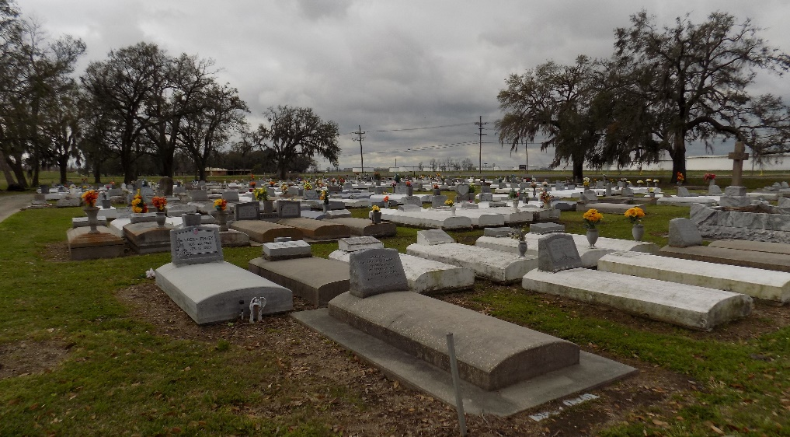

ST. JAMES – Velma Winifield, 80, a native of St. James and resident of Alexandria, Va., for the past five years, died Sept. 14. She was the wife of the late Thomas Winifield Jr. and mother of Judith Ambrose, Cecilia Harrell, Margaret Dorsey, Wilbert Hogan Jr. and Dianne, Paul Sr. and the late Thomas Winifield III. She was the sister of Prunelia Buggage and the late Maude Goodwin and Melvin Landry. She is survived by 21 grandchildren and a host of great-grandchildren.
Services are today at 11 a.m. at St. James Catholic Church, St. James, with interment at the church cemetery. Visitation starts at 9 a.m.
L’Observateur, Laplace, Louisiana
Sunday, September 23, 2001

