Gertrude (Haydel) Zeringue

February 15, 1925 – August 5, 2003

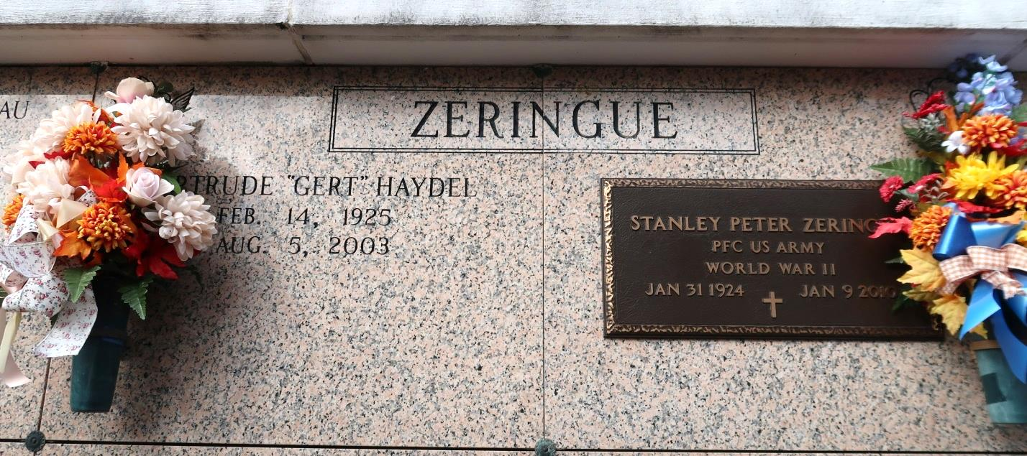

ST. JAMES - Gertrude Haydel Zeringue, 78, a native and resident of St. James, died Aug. 5. She was the wife of 57 years of Stanley Zeringue and mother of Brenda Allday, Claire LeBlanc, Mable Oubre, Peggy Trudeau, Connie Granier, Claudia Mistretta, Faye Ordoyne, Donald and Glenn Zeringue. She was also the daughter of the late Premilas and Claudia Landry Haydel, and sister of Mathilda Bourgeois, Adelaide Signorelli, Bertha Grangnard, Marilyn Rowan, Jeanette Carter, Joseph, Claude and Walter Haydel, and the late Beverly Haydel. She is also survived by 22 grandchildren and eight great-grandchildren. She is preceded in death by one grandchild and one great-grandchild.   
 Services were Aug. 7 at St. James Catholic Church, St. James, with interment at the church mausoleum

L'Observateur (La Place, LA)

Thursday, August 14, 2003<br>  
Contributed by Jane Edson