Henry John Zeringue, Sr.

January 1, 1926 – November 10, 2015

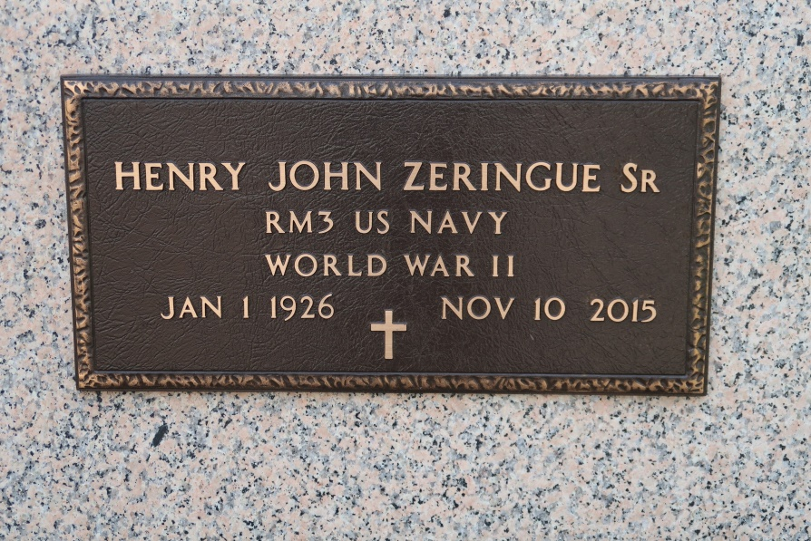

Henry John Zeringue, Sr. passed away on November 10, 2015, at the age of 89 years. A longtime resident of St. James, LA, Henry spent his last few years residing at the Magnolia Assisted Living Home in Gonzales, LA. He was born in Modeste, LA, but his father worked in various shipyards throughout the South, taking his family with him. After settling in St. James, his father established a farm equipment repair and manufacturing shop, Zeringue's Farm Equipment Service, that he worked in after he served in the U.S. Navy as a radioman during WWII.

He married Kathleen Schexnayder in 1948. In 1980, he became a Deacon in the Roman Catholic Diocese of Baton Rouge and served his deaconate at St. James Catholic Church. He loved his church and the parishioners, always attentive to their needs with love and compassion. He loved traveling, fishing, gardening, and woodworking. His greatest love was his family, grandchildren, and great grandchildren. He was a kind and gentle soul and was quick to joke with you. He sang in the choir at church for years and traveled about with a group that loved to do the same, spreading warmth and song wherever they could. He took many trips all over this country, to the Holy Land, to Rome, and to Medjugorje. He served Mass with two popes, John Paul I and II, in his travels to Rome.

He was preceded in death by his father, Jean Remi and his mother Lillia Josephine , his wife Kathleen, his brother, Percy, his sister Annabelle Schexnayder, and his sister Elise Henderson. He was survived by a sister, a brother, four sons, two daughters, 11 grandchildren, and 18 great grandchildren.   
 Mass of Christian Burial at St James Catholic Church in St. James. Entombment in church mausoleum

The Advocate, Baton Rouge, LA

unknown date