Kathleen Rose (Schexnayder) Zeringue

June 24, 1927 – December 8, 1998

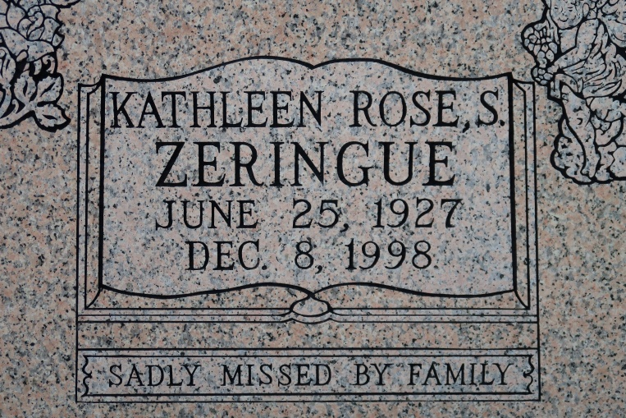

Kathleen Schexnayder Zeringue, 71, a native of Vacherie and a resident of St. James, died Dec. 8. She was the wife of Deacon Henry Zeringue and mother of six. She was the daughter of the late Gaston Sr. and Laura Waguespack Schexnayder and sister of Clara Mae Landry and brothers Gaston Jr. and Hubert Schexnayder. She was also survived by nine grandchildren and one great-grandchild.   
 Services were held Dec. 10 at St. James Catholic Church, St. James, with interment at the church mausoleum.

L'Observateur (La Place, LA)

December 14, 1998