Marie Cecile Zeringue

November 18, 1948 – February 11, 2016

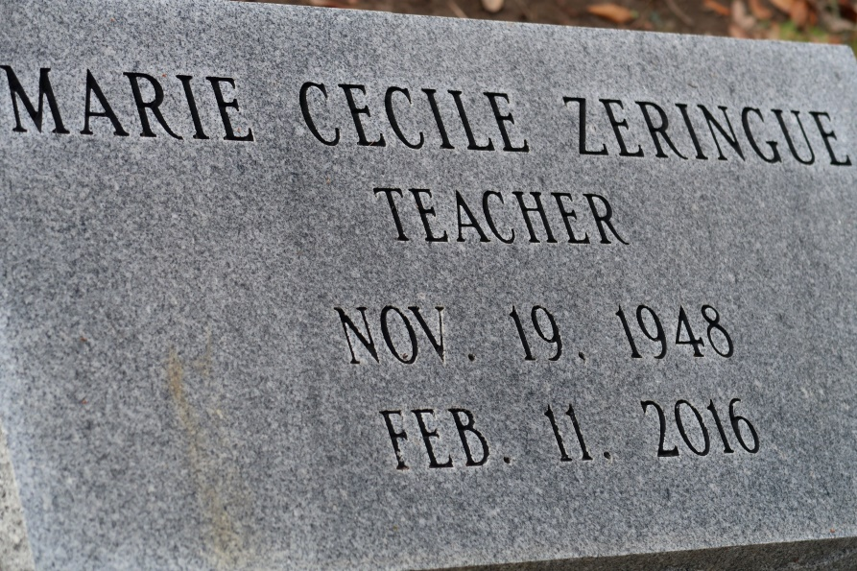

Marie Cecile Zeringue, 67, died on Thursday, February 11, 2016. She was a first grade teach teacher for 32 years in the St. James Parish Schools and a religion teacher for 20 years at St. James Catholic Church.

She is survived by her siblings, Nelson A. Zeringue Jr., Furcy J. Zeringue and wife, Anna, Patrick J. Zeringue and wife, Joanne, Alice Z. Brandt, John Zachary Zeringue and wife, Maxine; and14 nieces and nephews.

Preceded in death by her parents, Nelson A. Zeringue, Sr. and Eunice Granier Zeringue; brother, Timothy Paul Zeringue, Sr.; and sister-in-law, Mary Anne Zeringue.

Visitation will be held on Friday, February 19, 2016 at 8:00 a.m. until Mass of Christian Burial at 10:00 a.m. at St. James Catholic Church in St. James. Interment to follow in church cemetery. Arrangements by Ourso Funeral Home in Donaldsonville.

The Advocate, Baton Rouge, LA

Wednesday, February 17, 2016