Sharon (Simon) Zeringue

September 11, 1956 – August 23, 2021

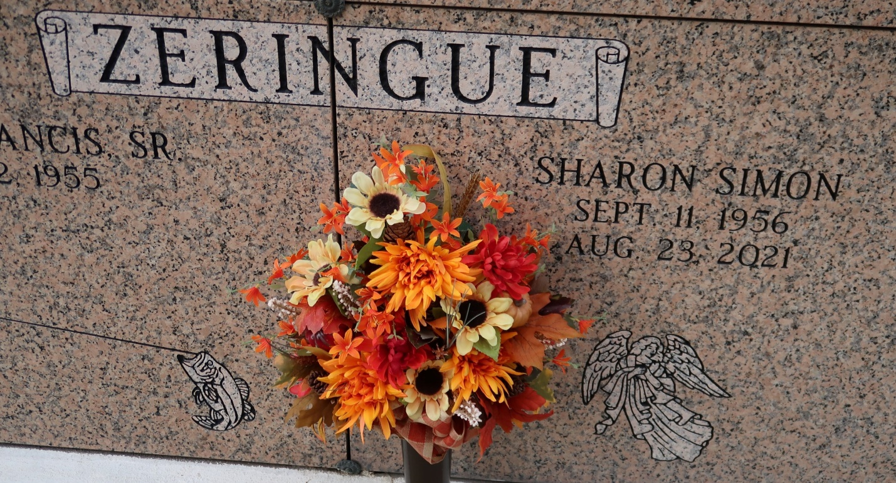

Sharon Simon Zeringue, 64, passed away at 1:27 AM on August 23 , 2021 peacefully at home with her family. She was a loving wife, mother, grandmother, and great-grandmother.

She is survived by her husband; Glenn Zeringue Sr.; daughter, Heather Zeringue; sons, Glenn (Kimberly) Zeringue Jr. and Floyd Zeringue; sisters, Donna (Don) Matte, Jolene Bourgeois, and Rhonda (Sandy) Kliebert; Brother in Law, Donald (Marilyn) Zeringue; Sister in Laws, Brenda Allday, Claire (Paul) Leblanc, Mabel (Ricky) Oubre, Peggy Trudeau, Connie (Jimmy) Granier, Claudia (Steve) Mistretta, and Faye (Claude) Ordoyne.

She was preceded in death by her parents; Floyd (Pluto) and Annie Lee Simon; Father and Mother in Law, Stanley and Gertrude Zeringue; sister, Wendy Louque; and best friend, Mary Prichard.

She loved spending time with family and friends whether it was just outside relaxing or at gatherings. She also loved making many memories with her sisters. She retired from the United States Postal Service after 17 years of service. She was a blessing to everyone she ever came in contact with and will truly be missed by many.

Thanks to Heart of Hospice staff for their excellent care, especially her nurse, Jessica. Special thanks to everyone else that helped with her care.

Visitation will be held on Wednesday, August 25 from 9 AM until a Mass of Christian Burial at 11 AM at St. James Catholic Church in St. James; burial to follow in the church mausoleum.

Dignitymemorial.com