Stanley Peter Zeringue

January 31, 1924 – January 9, 2010

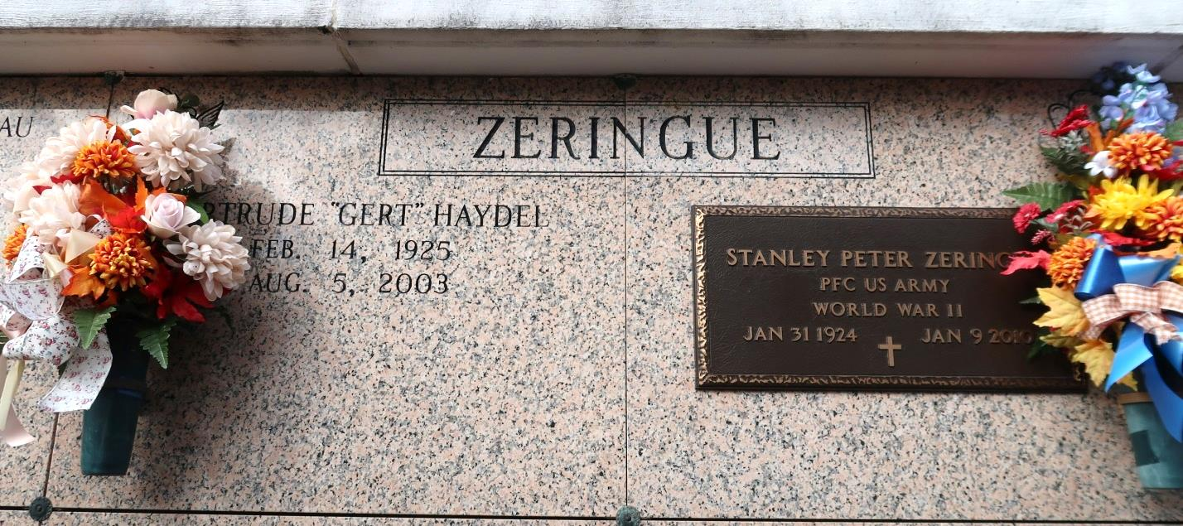

Stanley Peter Zeringue, 85, passed away at 5:58 p.m. on Jan. 9, 2010, at home.

Visitation will be held from 8 a.m. to funeral time Tuesday at St. James Catholic Church. Mass will be 11 a.m. Tuesday at the church with celebrant the Rev. Michael A. Miceli and interment to follow in the church mausoleum.

He is survived by his nine children, Brenda and Al Allday of Gonzales, Donald and Marilyn Zeringue of Donaldsonville, Claire and Paul LeBlanc of Labadieville, Mabel and Ricky Oubre of Vacherie, Peggy and Randall Trudeau of Millington, Tenn., Glenn and Sharon Zeringue of St. James, Connie and James "Jimmy" Granier of Chackbay, Claudia and Stephen Mistretta of St. James, and Faye and Claude Ordoyne of Prairieville; two brothers, Alfred and Gladys Zeringue of Husser, and Robert and Lillian Zeringue of Vacherie; one sister, Rita Mae and William Faulkner of Slidell; two sisters-in-law, Shirley and Betty Zeringue of St. James; 25 grandchildren; 37 great-grandchildren; and six great-great-grandchildren.  
 He was preceded in death by his wife, Gertrude Haydel Zeringue; his parents Furcy and Leah Zeringue; three brothers, James, Nelson and Allen Zeringue; one granddaughter, Bridget Mary Oubre; one great-grandson, Nicholas Falgoust; and one great-granddaughter, Carmen Alexis White. He was a loving husband, father, grandfather, great-grandfather, and great-great grandfather.

Stanley was a lifelong resident of St. James. He was employed by the Texas-Pacific Railroad, Missouri-Pacific Railroad Co. and the Union Pacific System Railroad for a combined 43 years. He was also secretary-treaurer for the St. James Parish Police Jury for 17 years. He served our country from July 1944-June 1946 during World War II. Stanley was also a member of Knights of Columbus.

Funeral arrangements by Ourso Funeral Home in Donaldsonville.

The Advocate, Baton Rouge, LA

Tuesday, January 12, 2010  
Contributed by Jane Edson