Louis Joseph Charles Babin Sr.
October 31, 1927 – July 25, 2024

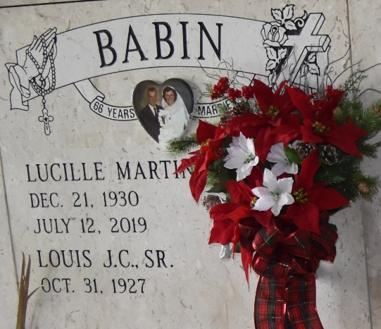

Louis Joseph Charles Babin Sr., a loving and devoted husband, father, grandfather, great-grandfather, and brother, passed away on Thursday, July 25, 2024, at the age of 96.
A native of Norco, LA and a resident of Paulina, LA since marriage, Louis was born on October 31, 1927 to Louis Joseph Babin and Marie Louise Thibodeau. He was a United States Army Veteran having been stationed in the Philippines during the Korean War. He retired from Shell Oil Refinery in Norco, LA after 40 years of service. He was an avid outdoorsman who enjoyed hunting and fishing.
Survivors include his children Edward Babin, Connie B. Chapman, Gail B. (Darryl) St. Pierre, Chris Babin, Joan B. (Kerry) Lambert, and Louis (Jacquie Owen) Babin Jr. Grandchildren Colin, Jared, and Adam Babin; Jeanine B. Coles; Karen C. Bridge; Matthew and Jacqueline St. Pierre, Craig and Trisha Babin; Lance and Jason Lambert; April L. Bienvenu, and Kerra E. Hardison. Great-grandchildren Kelsi, Kylee, Luke, Nate, Ava, and Owen Babin; Isaac, Jase, and Kaleb Coles; Lauren and Alexander Bridge; Kaylee and Katelyn St. Pierre; Jonathan Dedon; Brodie Johnson; Hannah, Paisley, Mackenzie, Emmett, and Sophie Lambert; Zachary Lehmann; Mark Jr. and Alexa Bienvenu. He is also survived by brothers Leo and Patrick Babin, sister Laura B. (Stephen) Deslatte, and numerous cousins, nieces, and nephews.
Preceded in death by his wife of 66 years Lucille Martin Babin, son Keith Babin, grandson Chad Babin, and daughter-in-law Jane Deroche Babin, brothers Norman and Michael Babin, sisters Velma B. (Lawrence) St. Amant, Margie B. (Elmer) Corley, Lois B. (Julius) Louque, and Marie B. (William) Todd.
Visitation will be held on Monday, August 5 from 9:00 a.m. – 11:00 a.m. at St. Joseph Catholic Church in Paulina, LA followed by Mass of Christian Burial at 11:00 a.m. Burial will follow in St. Joseph Mausoleum.
Memorial donations can be made to The Catholic Church of East St. James Parish.
The family would especially like to thank the Staff of Bridgeway Hospice Care – Felicia, Megan, and Chaplain Steve; Home Instead Caregivers – Casey and Laverne; and Dr. Randall Poche with Poche Medical Clinic.

Rose Lynn Funeral Home, Lutcher, Louisiana
July 27, 2024

