Linda Ann (Williams) Bailey
January 13, 1953 – August 10, 2024

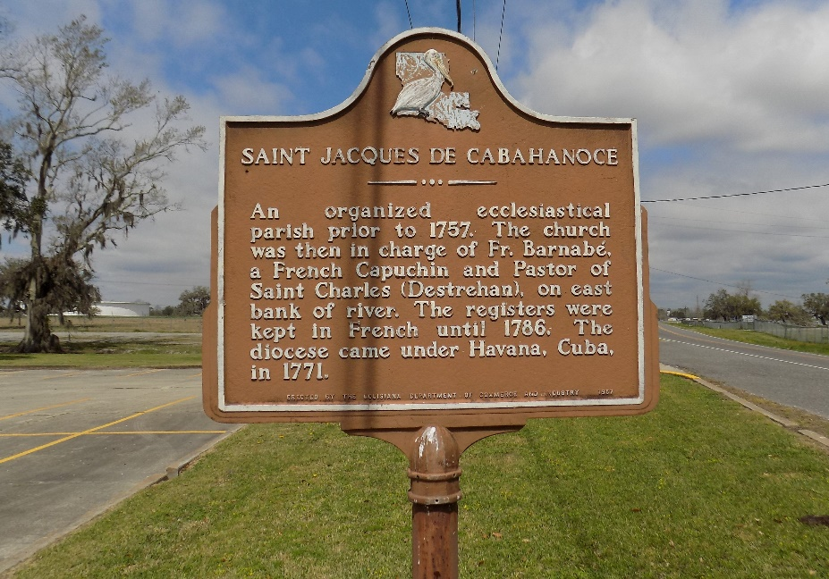

On January 13, 1953, proud parents Vivian Jackson Williams and Abraham Williams Sr. welcomed their baby girl, Linda Ann Williams, who was born in New Orleans, LA. Linda was the sixth child born to this union and the youngest girl, joining siblings Abraham Jr. “June,” Carolyn, Kathleen and Clarence “Gary” and her aunt who her parents raised, Audrey Jackson “Autie,” in the family home in Gramercy, LA. One year later, her baby brother Percy was born, completing her family unit.
Linda grew up in a loving and activist home, often witnessing her father engaging in union activities and fighting segregation through voting drives. But more than anything, their home was a Christian home where days began and ended with prayer and Sundays were filled with church services. This Christian upbringing served as the foundation for Linda’s life. She accepted Jesus Christ as her Lord and Savior and was baptized by Rev. Herbert Gordon with her brother Gary and other neighborhood friends at Golden Grove Baptist Church in the Summer of 1966. She served faithfully at Golden Grove until 1980 as a secretary until she decided to join Antioch Baptist Church, where her brother-in-law Ferdinand Gaines, Jr. was the pastor. She continued her secretarial duties at Antioch working in a very small office and using the communion table to count money. She continued her service as church secretary when the church moved to its current location – First Community Antioch Baptist Church, August 1999. Linda found a love for singing, joining the FCABC mass choir in addition to working as the choir secretary.
Linda’s parents also stressed the value of an education. She matriculated through the segregated schools in St. James Parish, but graduated just as the schools were being integrated from Lutcher High School Girls Division in May 1971. Linda followed in her older siblings’ footsteps and attended her beloved Southern University, receiving a BS in Business Education in May 1975. She remained a faithful and devoted SU Jag alumnae, supporting the alumnae association and the football team as a 30 year season ticket holder.
Linda credits Southern University with providing her with a first-class education, but it was also there, in the commuter bus parking lot, that she met her soulmate and life partner, Lionel L. Bailey, Sr. The two were married on March 22, 1975 and from that union, Alicia Ann and Lionel Jr. were born. They lived in Lionel’s hometown of Edgard until 1999 when they moved to Linda’s hometown of Gramercy to be closer to family.
Linda was a devoted wife and mother who faithfully and diligently attended to the needs of her household. She was very crafty and loved scrapbooking, journaling and reading Christian books. She taught her daughter how to sew, cook and bake. Linda began her career as a pre-school/kindergarten teacher, even teaching her daughter during that time. She later worked in the LSU Agricultural County Office from 1980-1993. She decided to go back to teaching in the public schools of St. John Parish in 1993 until her retirement in 2015. She taught Business classes—accounting, business computer applications, and COE (Cooperative Office Education). Each year, she worked to train students in business, giving them work opportunities with local businesses/industry partners. She believed in maintaining relationships with her students, enjoying many of those relationships up until her death.
Linda’s life centered on her family—both her immediate family and her extended family. She relished family gatherings—whether those were at her sister Carolyn’s home or a local restaurant. She loved spending time in Dallas with her grandchildren, taking them to Dave & Busters to play games. Everyday, you could find Linda and Lionel either spending time together or on facetime with their children and/or grandchildren. In this last year, she requested a 70th party for her husband and for the family to take her grandkids to Disney World. Her desires were fulfilled when a month before her death, the entire family went to Disney World.
Linda left her earthly home to live with Christ on August 10, 2024 She leaves to cherish her many precious memories, husband Lionel Sr.; children Alicia and Lionel Jr., daughter-in-law Alanna Robinson Bailey; grandchildren Adalyn, Avery, Annalise and Alexander Bailey; brother Percy Williams; brother-in-law Edward Johnson; sisters-in-law Katherine Williams and Lilly Bailey; devoted niece and nephew Connie and Jacque Jackson; and a host of nieces, nephews, relatives and friends.
Linda is preceded in death by her parents—Abraham Williams, Sr. and Vivian Williams; siblings—Abraham Jr. and Clarence Gary Williams, Carolyn Williams Gaines and Kathleen Williams Johnson; godson—Calvin Nabors, Jr; parents-in-law—Leroy Bailey Sr. and Victoria Bailey; sister-in-law—Beatrice Williams; brothers-in-law Pastor Ferdinand Gaines, Jr. and Leroy Bailey Jr; nieces Deann Johnson and Nikki Bailey, nephews Edward Kendall Johnson and Jayson Williams.
A celebration honoring her life will be on Saturday, August 17,2024 at First Community Antioch Baptist Church, 10860 LA-3125, Lutcher, LA 70071. Viewing period begins for 12:45pm followed by service for 2pm. Entombment St. Joseph Cemetery, 2130 Rectory St., Paulina, LA 70763.

Treasures of Life Funeral Services, Gramercy, Louisiana
August 16, 2024

