Ora Belle (Williams) Bazile
Aug. 25, 1939 - Aug. 27, 2024

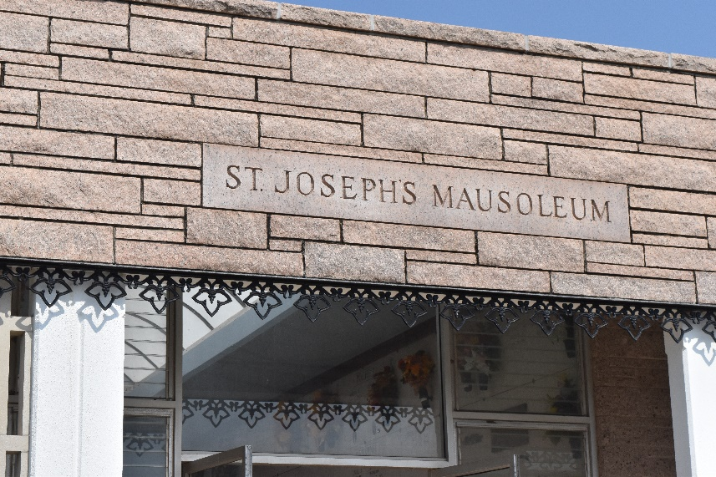

On Tuesday, August 27, 2024, Minister Dr. Ora Belle Bazile departed this earthly life surrounded by her loving children while they held her hands. Dr. Ora Belle Bazile was born on August 25, 1939, to the union of Rev. James Williams Sr. and Lillian Brown Williams in Ponchatoula, Louisiana. The household was a blessed and Christian home where both of her parents loved to praise the Lord. Her parents believed that their family’s blessing was the favor of God. And a favorite scripture often repeated in the home was Joshua 24:15, “but as for me and my house, we will serve the Lord.” Her father, the late Rev. James Williams Sr., taught her about the fear and admiration of the Lord and Savior Jesus Christ. Additionally, he instilled in Dr. Bazile the importance of loving God and to always have a sermon prepared on her lips for the people of God. As she continued to grow in Christ, her favorite scripture became Romans 8:28 which states: “And we know that all things work together for good to those that love God, to those who are called according to His purpose.” On September 9, 1951, Dr. Bazile was baptized at Greater King Triumph Baptist Church by her father, the late Rev. James Williams Sr., and Rev. W. M. Fluence. Excitedly growing in Christ, she became a member of the choir and taught Sunday School.
Minister Dr. Bazile matriculated through the St. James Parish School System. She graduated from Cypress Grove High School in Lutcher, Louisiana in 1958. During her high school years, she was an outstanding basketball and softball player. She also excelled in track and field. Upon graduation, she enrolled at Southern University A&M College in Baton Rouge, Louisiana where she graduated in 1963 with a Bachelor of Arts in Secondary Education and later with her Masters and plus 30 on August 6,1966. On May 15, 1996, she furthered her Christian studies at Union Baptist College & Theological Seminary earning a Master of Christian Education degree. Later, she earned her Doctor of Theology from A.P. Clay Christian Theological College on May 29, 2011. As a diligent worker in God’s vineyard, Minister Dr. Bazile became licensed to preach the gospel at King Solomon Baptist Church by Reverend Benjamin Scott. At this church, she founded the Women’s Ministry of King Solomon Baptist Church, she was a part of the Senior WOW (Wings of Wisdom) and worked Vacation Bible School each summer. She affiliated with other churches in the community and worked with the Woman of Nobility at St. Joe Baptist Church with her brother Bishop Clarence Williams. Dr. Bazile's christian walk extended to the New Generation Fellowship under the leadership of Bishop E. Craig Wilson, where she was a part of the Ministerial Alliance. Additionally, she had a radio ministry from 1991-1998 WCKW Radio teaching the weekly Sunday school lessons called “The Bible Speaks Today” then again from 2015-2018.
Her dedicated services as Eastern Star, earned her the awarded the title of Past Worthy Matron by the Olive Branch Chapter #119. In her early days of teaching, she taught at East Baton Rouge Parish School System. Then later serving for 35 years at St. James Parish School System, 3 years at John Curtis Christian School, 2 years at St. John The Baptist School System where she taught Health and Physical Education, Civics, American History and Free Enterprise. She coached basketball, softball, track and field. In 1984 and 1986, she was awarded National Coach of The Year. In 1984 and 1985, she and her girls track won Girls Track and Field State Championships. As a track coach she was motivating, stern and loving becoming a motherly figure to many of her track girls. At Lutcher High School, she was the cheerleading coach. In addition to being the founder of the Girls Biddy Basketball for St. James Parish.
To the union of Louis Morris Sr., she bore Renee’ L. Morris and Louis Roderick Morris in holy wedlock. Later remarried on July 9, 1979, to Charles Joseph Bazile Sr, and had Cornell Bazile in holy wedlock.
Minister Dr. Bazile loved her Lord and Savior Jesus Christ and to inspire others along their Christian journey. She loved her alma mater Southern University and eagerly anticipated the yearly rivalry between Southern and Grambling. She was known for talking “big smack” and being “plenty messy.” She enjoyed watching the Jackson State University "J5" Drum Majors. She was an avid sports fan, and thought highly of Deion Sanders. Her favorite foods included gumbo, fried fish (fried hard!) and pecan candy. If she was going somewhere whether to church, a sporting event, etc, etc. she had to be on time because she believed in being punctual. Her favorite show was Family Feud with Steve Harvey.
Minister Dr. Bazile leaves to cherish her many precious memories to her children, Renee’ L. Morris-MaGee, Louis Roderick Morris Sr., (Dionne), and Cornell James Bazile (Janel), Elder Cynthia Joshua, Charles Bazile Jr., Minister Robin Bazile-Garnett, Kevin Bazile, Bruce Bazile; grandchildren Ricky D. MaGee Jr., (Shaniya), Donniel MaGee (Diamond), Kairie S. MaGee, Sharnika LeBlanc (Brandon), Roderick Nadie (Verica), Ra’Janae Morris, Taiya Morris, Amaya Morris, Louis Morris Jr., Sanaya Morris, Prentice Cook, Dariyel Duhe, Danel Duhe, Raiyel Duhe; greatgrandchildren Malachi MaGee, Diya MaGee, Semaj Nadine, Se’Myre Nadie, Reminisce Nadie, Brandon McKnight, Bailynn McKnight; Jayce Taylor, Daniel Duhe, Jr., sisters: Lillian Price, Nitrea Allen (Vincent), Mary Louise Nelson, and Vanessa (Terry) Johnson; Brothers: Roosevelt (Shirley) Preston, Charles and Irvin Preston, Elder Theron Jones. Goddaughters: Minister Kathleen Lee, Estilita Johnson and Lucy Bermond. Also, she had many adopted sons, and daughters and a host of nieces, nephews, cousins and friends all of whom she adored.
Minister Dr. Bazile was preceded in death by her husband Charles Joseph Bazile, Sr., her father James Williams Sr., her mother, Lillian Brown Williams, her father-in-law Joseph Bazile Jr.; and mother-in-law Puliska Bazile; Brothers: Johnny Traville, Thomas Price Sr., James Williams Jr.,; Nephews: Tyrone Williams, Wendell Price, Johnny Price Sr., Vincent L. Price, Rodney Phillips; Aunts: Irene LeBray Scott, Leola Browser; Uncles: Arthur Williams, Hermon LeBray Sr., Alvin LeBray Sr., Isaiah Brown, Freddie Brown. Brother-in-law: Alvin Price; Sister-in-law Clarice Price; Son-in-law Ricky D. MaGee Sr.
A gathering of family and friends will be held on Friday, September 6, 2024 from 5-7pm at Treasures of Life Funeral Services, 315 E. Airline Hwy., Gramercy, La 70052. A celebration service honoring her life and legacy will be held on Saturday, September 7, 2024 at King Solomon Baptist Church, 2385 N. Courseault Street, Lutcher, La 70071. Visitation begins for 8am followed by service for 10am. Entombment to follow at St. Joseph Catholic Cemetery, 2130 Rectory Street, Paulina, La 70763.

Treasures of Life Funeral Services, Gramercy, Louisiana
September 6, 2024

